

North South University
Department of Electrical and Computer Engineering

Project Name
Bike Store Management System Course Name: Junior Design Course Code: CSE299
Section: 12
Group: 05

Serial Number | Full Name | ID
01 | Md. Munam Rahman | 2222824042
02 | Junain Nasir Joy | 2011137642

Supervisor:

Ms. Syeda Sarita Hassan [SSH1]
Senior Lecturer

Department of Electrical & Computer Engineering North South University, Dhaka

ABSTRACT
Bike Store Management System

In today’s competitive market, speed and efficiency can make the difference between success and struggle for a business. Many bike retail stores still depend on manual processes or scattered digital tools, which often cause delays, errors, and poor inventory control. To address these issues, this project develops a web-based “Bike store management system” that brings every key operation under one platform. From organizing products and managing stock levels to interacting with customers and generating invoices, the system is designed to replace repetitive manual work with smart automation. Built with a structured database, an easy-to-use interface, and reliable data handling, it ensures smooth operation for both administrators and customers. Testing showed faster transactions, more accurate inventory tracking, and quicker customer responses. By reducing workload and improving service quality, the system proves to be a practical and impactful solution for modernizing bike store operations.

TABLE OF CONTENTS
ABSTRACT 1
LIST OF FIGURES 4
LIST OF TABLES 4
Chapter 1 Introduction 5
  - Background and Motivation 5
  - Purpose and Goal of the Project 5
  - Organization of the Report 5
Chapter 2 Research Literature Review 6-7
  - Existing Research and Limitations 6-7
Chapter 3 Methodology 8-10
  - System Design 8
  - Hardware and/or Software Components 8
  - Hardware and/or Software Implementation 8-10
Chapter 4 Impacts of the Project 11-12
  - Impact of this project on societal, health, safety, legal and cultural issues 11
  - Impact of this project on environment and sustainability 11-12
Chapter 5 Project Planning and Diagrams 13-14
Chapter 6 Complex Engineering Problems and Activities 15-17
  - Complex Engineering Problems (CEP) 15-16

  - Complex Engineering Activities (CEA) 16-17

Chapter 7 Conclusions 18-19

  - Summary 18

  - Limitations 18

  - Future Improvement 18-19

References 20

LIST OF FIGURES
Figure 1. Gantt chart of 299 tech shop 13
Figure 2. Schema Diagram 13
Figure 3. ER Diagram 14

LIST OF TABLES
TABLE I. A COMPLEX ENGINEERING PROBLEM ATTRIBUTES TABLE 15-16
TABLE II. A COMPLEX ENGINEERING PROBLEM ACTIVITIES TABLE 16-17

Chapter 1 Introduction

Background and Motivation :
The bike store management system is a web- based application for managing bike retail store activities. With this system, we can automate everything from organizing the product, interacting with customers, sending stock alerts, generating invoices, and more. We are going to digitalize everything. The system will provide an enhanced UI/UX, data integrity, and easy access for customers and administrator users.
The system can be used for better management of bike sales and inventory in an efficient manner while providing a high-quality experience to the customer without increasing the manual workload.

Purpose and Goal of the Project
This project aims to design and implement a web- based bike store management system to automate and optimize daily retail operations. Key features include product organization, customer interaction, stock alerts, invoice generation, and inventory tracking. The goal is to deliver a user- friendly platform with enhanced UI/UX, strong data integrity, and easy access for both customers and administrators—improving efficiency,
reducing errors, and providing high-quality service without extra manual work.

Organization of the Report
This report is divided into eight chapters. Chapter 2 is a literature review of existing websites in e-commerce and also its limitations. Chapter 3 explains the methodology used in developing the system, including the system design, software components, and implementation details. The experimental setup, testing procedures, results, and discussion of key findings are written in Chapter 4. Chapter 5 goes into detail on how this project may affect social, legal, environmental, and cultural aspects, including sustainability considerations. Chapter 6 outlines the project planning timeline. Chapter 7 outlines Complex Engineering Problems (CEPs) and Complex Engineering Activities (CEAs). Finally, Chapter 8 concludes the report with a summary, discusses current limitations, and suggests areas for future improvement. The References section at the end lists all sources cited throughout the report in IEEE form

Chapter 2 Research Literature Review

  - Existing E-commerce Sites and Limitations
Over the years, researchers and developers have worked on different e-commerce platforms to improve how customers shop online. They often built a website where users could log in, search for products, and add them to a shopping cart. While this covered the basics, it did not go much further in terms of helping customers compare items or filter products easily. On the other hand, some websites focused on inventory management for retail shops, creating a PHP-based system that could track available stock. Their solution worked well for small stores but lacked advanced features like sales analysis, invoice generation, or discount management—things that are essential for store owners to make smart decisions.
Larger e-commerce platforms such as Amazon and Flipkart have highlighted their success in offering huge product catalogs, personalized recommendations,
and advanced analytics. However, these platforms are very generalized and often too costly or complex for small businesses.
More importantly, they do not address the specific needs of niche stores like bike retailers, where customers often want features such as product booking, test ride reservations, or bundled accessories.
From these studies, it is clear that while e- commerce has advanced a lot, there are still some gaps when it comes to smaller, specialized stores. Some of the major limitations include:
    - Basic product display: Most small systems only allow browsing products by category, without advanced options like filtering by brand, comparing products, or grouping accessories together.

    - Limited personalization: Features like booking a product or applying exclusive discounts for logged-in users are often missing.

    - Lack of managerial tools: Store owners get very little insight into their sales performance. Features such as best-selling product reports, monthly or yearly sales tracking, and

automatic invoice generation are rarely included.

    - Weak customer communication: While large platforms use chatbots and email campaigns, smaller systems often lack even basic options to contact customers through email or phone.

    - Stock management issues: Synchronizing stock across different product categories (like bikes, scooters, oils, and helmets) is usually poorly handled, leading to
mismatches between what’s online and what’s actually available.

    - No recommendation system: Unlike big platforms such as Amazon, small e-commerce sites rarely suggest related products or make personalized recommendations. This means customers often miss out on products they might have been interested in, and stores miss out on potential sales.

These shortcomings highlight the need for a

dedicated bike store management system
that combines a smooth customer experience with powerful management tools. On the customer side, this means easy navigation, category and brand filters, product comparisons, discounts, and booking
options. On the manager’s side, it means being able to add or update products, analyze sales, generate invoices, track stock, and interact with customers directly. By addressing both sides, the proposed system aims to fill the gaps left by existing solutions and provide a more complete and specialized platform for bike retailers.

Chapter 3 Methodology

System Design
    - Architecture: The project uses a client- server architecture. The client uses an interface in the form of a website. The website then interacts with the backend, which sends back information. The client can then see the information on the interface.
    - Front-End Design: This was made using HTML, CSS, and JavaScript. HTML and CSS were used for the structure and style of the webpage, and JS was used to give functionality to all the buttons and drop- down menus.
    - Backend: The backend was mostly written in PHP, and we used Python for the recommendation system. All of the data was saved in the MySQL database.

Hardware and/or Software Components
    - Hardware:
      - Server: The website is hosted locally on a laptop.
    - Software:
      - Frontend:
        - Html: Webpage tables and structures.
        - CSS – basic styling.
        - JavaScript – dynamic content rendering and registering user activity.
      - Backend:
        - PHP: used for server-side scripting, handling user requests, and managing database interactions.
        - Python: server-side
scripting and integration with the recommendation system.
        - MySQL: Used to save
data for the website.

Hardware and/or Software Implementation
The implementation of the system is in two phases: Frontend Development and Backend Development.
    - Frontend Development:
      - User Interface:
        - Signup and login: Users need to signup and login to book products and get discounts.

        - Navigation Bar: A dynamic navigation bar is available for the users with multiple features and dropdown menus.
        - Product Browsing: Users
can view(Dropdown menu) and search products(e.g., Bike, Scooter, Helmet, Engine oils, Accessories) from the navbar, filter by category (e.g., Brand, Product type, Price) by sidebar, and check detailed specifications.
        - Compare Products: Users
can compare up to three products according to their choice by searching for the names and see their information side by side.
        - Cart: Two different kinds
of cart are available. One for the current session booking track keeping, and the other one is to keep track of the whole history of buying and booking for the user with
filters(e.g., week, year, full) available.
        - Recommendation: The
system will recommend products to the users according to their browsing, booking and buying history.
        - User Profile: Users can
see their informations and change password.
        - Footer: The footer gives
the users a quick understanding of the website and shortcuts for different links/pages.

      - Manager Interface:
        - Login: The manager has to login using the hardcoded email and password to enter the manager interface.
        - Dashboard: The
homepage/dashboard of the manager ui helds track of sales and bookings with filters.
        - Add, Update, and Delete:
Manager has the options to add new products to the

shop, update their quantity, and remove them from the website also.
        - View: Manager can see
the information of the customers(e.g., Name, Email, Contact no), history of sales and bookings, and can also see . the available products in
the shop.
        - Generating Invoice and sales track: The manager part of the website gives the manager the option to generate an invoice after the sale is confirmed. Manager can also print or create a PDF of the sales and bookings track by using filters.
    - Backend Development:
      - Product Data Management: All the products and brands are being shown from the database, and the information of browsing and user login/signup are also being saved the the database in different tables.
- PHP: PHP handles dynamic interaction with the database, ensuring that product details, brand information, and user login/signup data are retrieved, displayed, and stored efficiently across different tables.

Chapter 4 Impacts of the Project

Impact of this project on societal, health, safety, legal and cultural issues
The Bike Store Management System can make a real difference in how people buy bikes and accessories. For customers, it makes shopping much easier—allowing them to browse products, compare options, book items, and track discounts—all from home. This convenience can save time and reduce the stress of visiting multiple stores, while also making pricing and stock information more transparent.
From a health and safety perspective, the system encourages safer choices. By bundling helmets, engine oils, and other safety gear with bike purchases, it reminds customers to prioritize safety. The test ride booking feature also helps organize visits, preventing overcrowding and keeping safety procedures manageable.
There are also legal considerations. Since the system stores personal information like email addresses, contact numbers, and
purchase history, it’s important to protect
this data and follow privacy regulations. Digital invoices and records also provide clarity and reduce the risk of disputes between customers and the store.
Cultural factors come into play as well. In some areas, people still prefer visiting a store and negotiating in person, while younger, tech-savvy customers enjoy the convenience of online browsing, comparing, and booking. By combining both approaches, the system can help bridge traditional shopping habits with modern digital trends.
In short, this system not only makes shopping smoother and safer but also requires careful handling of customer data and respect for local shopping cultures to succeed.

Impact of this project on environment and sustainability
The Bike Store Management System can help the environment in practical ways. By using digital invoices, online catalogs, and product information, it reduces the need for paper, cutting waste. Customers can plan visits more efficiently, avoiding unnecessary trips and lowering fuel use and emissions.

For the store, better inventory management means less overstock and reduced waste of products like engine oils or helmets.
Promoting quality bikes and safety gear also encourages longer-lasting, well-maintained vehicles, which saves resources over time.
Overall, the system not only makes shopping easier but also supports environmentally friendly practices and sustainability.

Chapter 5 Project Planning and Diagrams
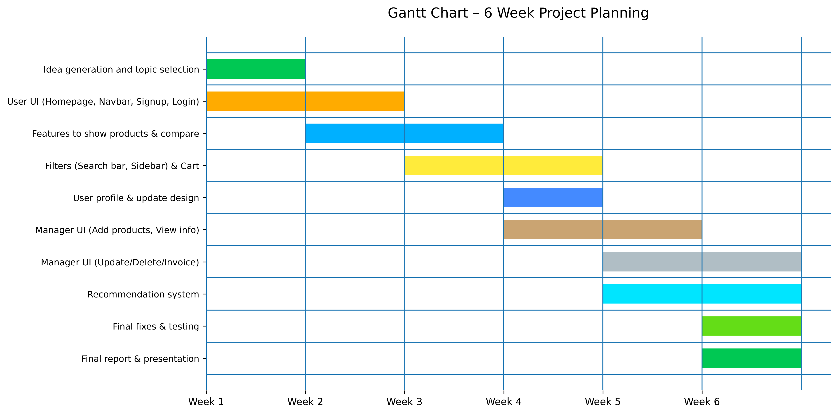
Figure 1. Gantt chart – 6 week Project Planning

Project Timeline / Work Plan
Week 1: Idea Generation, Requirement Analysis & Initial User Interface Design
Week 2: User Interface Development & Product / Feature Module Implementation
Week 3: Product Display Features, Filtering System & Cart Development
Week 4: Cart System Completion, User Profile Module & Manager Interface (Basic Functions)
Week 5: Manager Interface (Advanced Functions) & Recommendation System Integration
Week 6: Final Fixes, System Testing, Debugging, Documentation & Final Presentation

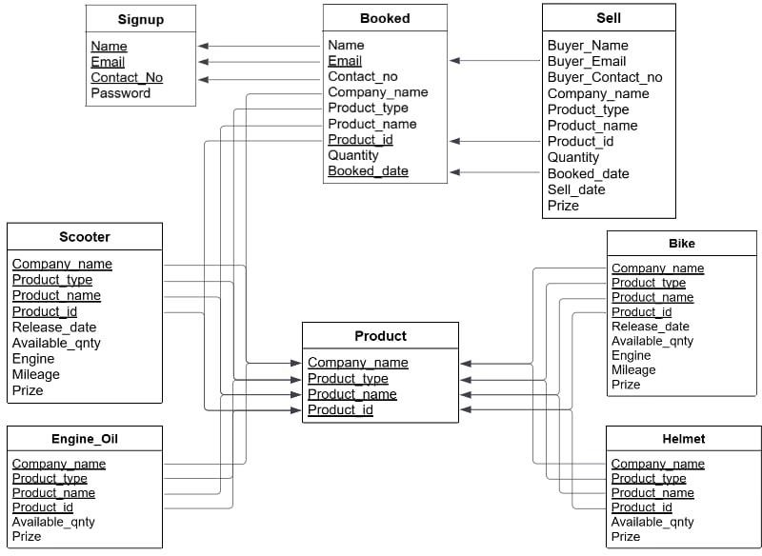
Figure 2. Schema Diagram

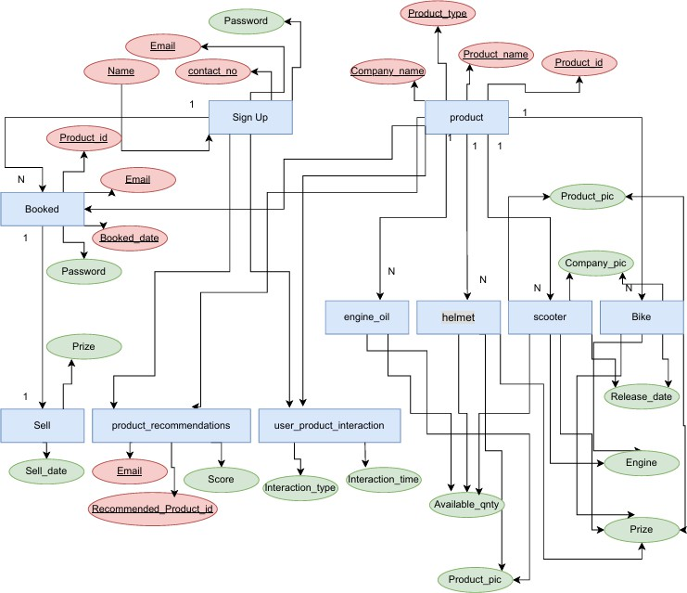

Figure 3. ER Diagram

Chapter 6 Complex Engineering Problems and Activities
related to the capacity
of the motors.
P3 | Depth of analysis required | No unique way to design. Depth of analysis needed to select a specific solution from many alternatives. (Static/mobile/drone.  Various microcontrollers. Various sensors)
P4 | Familiarit y of issues | Various air quality sensors, Raspberry Pi/Arduino Mega/Nano/Uno/Nod eMCU  Microcontroller.
P5 | Extent of applicabl  e codes | There is no existing code or standard for  this project.
P6 | Extent of stakehold er involvem ent | There are several stakeholders needs to be involved including the owner of the device, installing places, Ministry of  Environment, etc.
P7 | Interdepe ndence | Project involves a number of interdependent sub- systems such as microcontrollers, sensors, wireless communication system, circuit designing tools,  mobile apps.

Complex Engineering Problems (CEP)

Attributes |  | Addressing the complex engineering problems (P) in the project
 |  | The project requires
 |  | knowledge of
 |  | Electrical Circuits,
 |  | Electronics (K3),
 |  | Wireless
 |  | Communication,
 |  | Embedded System,
 |  | Sensors and
 | Depth of | Instrumentations
P1 | knowledg  e required | (K4), Designing and  Simulation (K5),
 | (K3-K8) | Engineering & IT
 |  | (Circuit
 |  | Design/Smartphone
 |  | Application) Tools
 |  | (K6), Involve
 |  | Environmental
 |  | Effects (K7),
 |  | Scientific Research
 |  | Papers (WK8).
 | Range of | In the prototype, the strength of the structure (mass) and capability of  weightlifting (# of sensors) is directly
 | conflictin
P2 | g
 | requireme
 | nts

P1 Depth of knowledge required: This project requires knowledge of web development and databases, PHP,

JavaScript, HTML/CSS, and MySQL, and system design and UI/UX principles. It involves using development tools like VS Code, XAMPP, and GitHub, while considering user experience, security, and performance. The project also draws on research and case studies of existing management systems to guide best practices.
Attributes |  | Addressing the complex engineering activities (A) in the project
A1 | Range of resources | This project involves human resource, money, modern tools (simulation software/mobile  APP), hardware components, etc.
A2 | Level of interaction s | Involves interactions between different stakeholders including group members to design the device, installing places, Ministry of Environment to  collect data, etc.
A3 | Innovation | Employs innovative skills of engineering by introducing technology in a different manner in the environment and IoT sector
A4 | Consequen ces to society  / Environme nt | Impact in our environment since it helps to monitors the air quality data and measure AQI
A5 | Familiarity | Needs to be familiar with the various sensors, microcontrollers, wireless communication system, circuit

P2 Range of conflicting requirements: In the system, there is a trade-off between feature complexity and performance. Adding more functionalities like product comparisons, real-time cart updates, or detailed reports can impact loading speed and responsiveness, so a balance must be maintained to ensure a smooth user experience.

P6 Extent of stakeholder involvement:
Several stakeholders are involved in the project, including store owners, customers, sales staff, and system
administrators, as their input is essential
for designing features, managing inventory, and ensuring the system meets real-world business needs.
  - Complex Engineering Activities (CEA)

designing tools, mobile apps. UN SDG #04: Quality education; UN SDG #10: Reduce
inequality

A1 Range of Resources: This project involves human resources, budget, software development tools (IDE, database systems), and hardware resources such as servers or testing devices to build, deploy, and maintain the system.

A2 Level of Interactions: The project involves interactions between team members, store owners, customers, and system administrators to design, develop, and test the system effectively, ensuring it meets business and user requirements.

Chapter 7 Conclusions
  - Summary
The Bike Store Management System is a web-based application designed to streamline the operations of a bike retail store. It allows store owners and staff to manage inventory, add or update products, handle bookings and sales, and generate reports efficiently. Customers can browse products, view details, compare items, and place orders through an intuitive interface. The system integrates PHP, JavaScript, HTML/CSS, and MySQL, supported by modern development tools, ensuring smooth performance, data integrity, and a user- friendly experience. By digitizing store management, the project improves efficiency, accuracy, and customer satisfaction, while providing a scalable solution for future enhancements.

  - Limitations

    - Scalability Constraints: Handling a very large number of users or products may require server upgrades and optimization.

Hardware Dependence:
Performance depends on the user’s device or server specifications.

    - Limited Automation: Certain tasks like stock delivery, physical inventory checks, and in-store customer assistance are not automated.

    - Security Risks: As with any web- based system, it is susceptible to potential cyber threats if security measures are not strictly maintained.

    - Maintenance Requirements: Regular updates, bug fixes, and database management are needed to keep the system running smoothly.

  - Future Improvement
    - Online payment integration – The system can be enhanced to accept secure payments via SSLCommerz, Bkash, and Nagad.

    - Mobile app version – A mobile application can be developed for

easier access and improved user convenience.

    - Chatbot integration – A 24/7 chatbot can be added to provide instant customer support.

    - Forgot password – Users can be given an option to reset their password securely if forgotten.

    - Buy second-hand bikes – The system can include a feature for listing and purchasing second-hand bikes.

    - Guess bike price – A feature can be added to estimate bike prices based on specifications and market trends.

    - Contact with customers – The system can allow direct communication with customers via email or contact number for support and promotions.

References
      - https://suzuki.com.bd/
      - https://www.yamahabd.com/
      - https://www.bikebd.com/
      - https://www.heromotocorp.com/en- bd/price-list.html

Snippets(Customer Part):
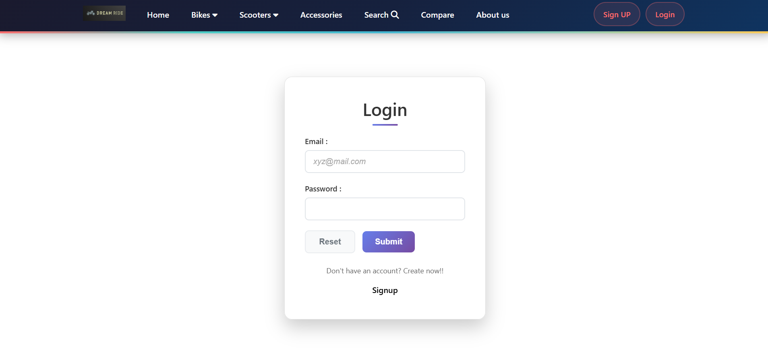

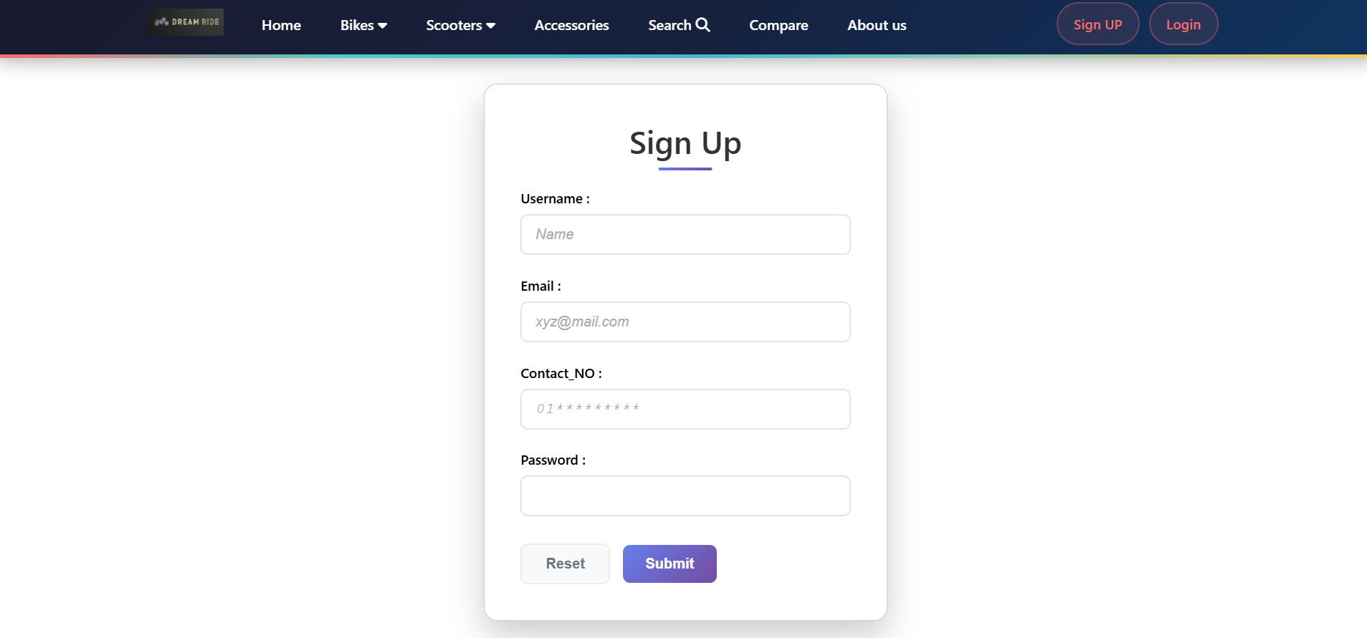

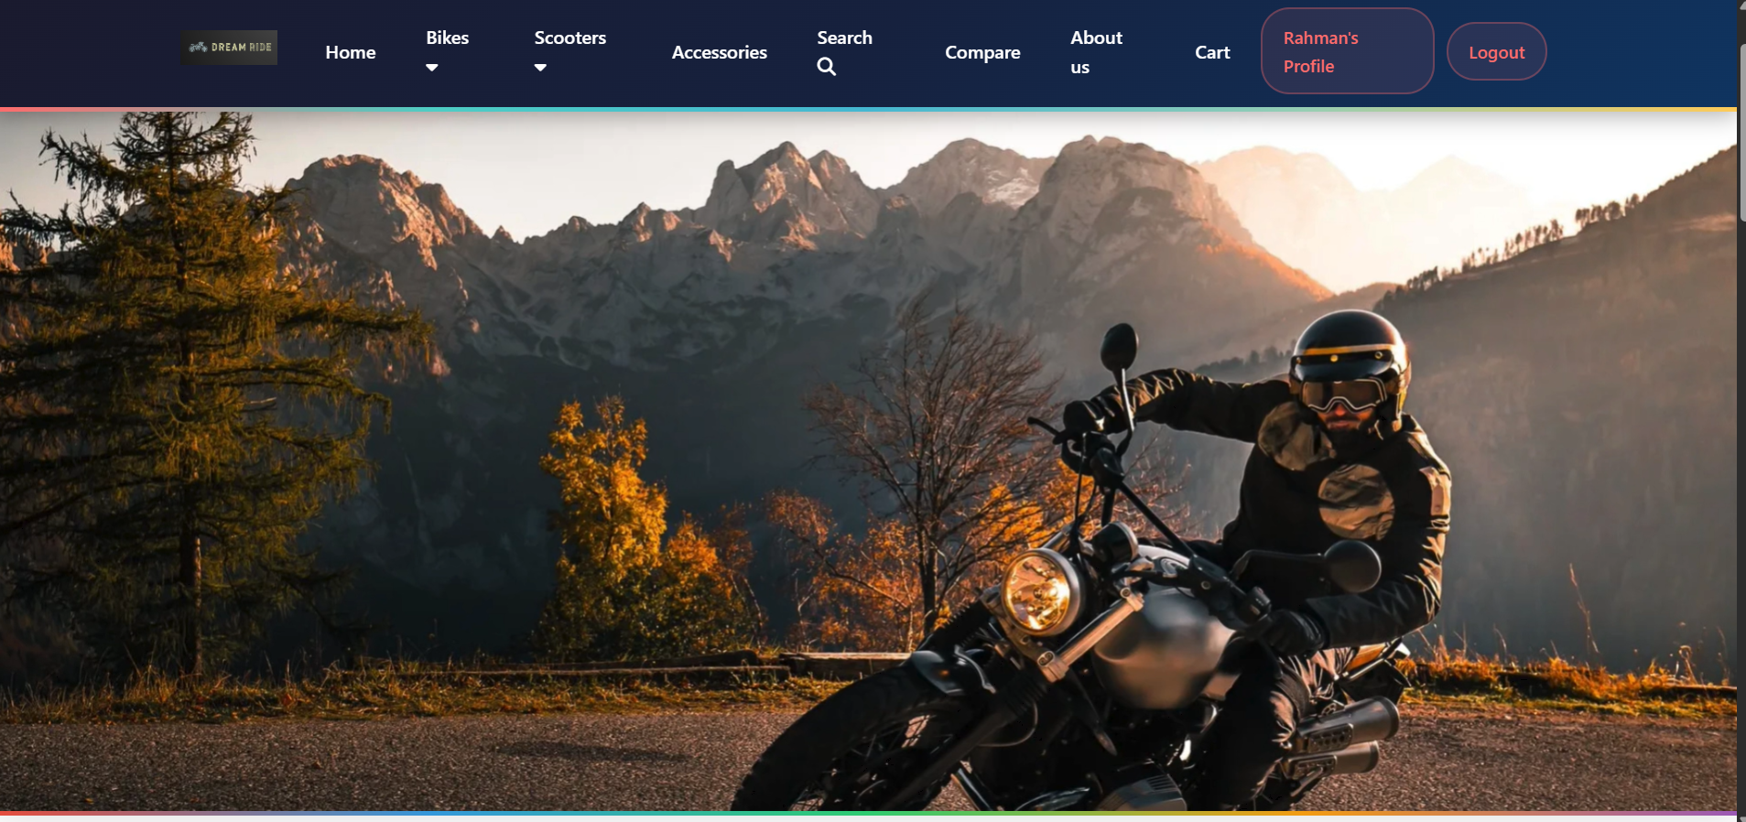

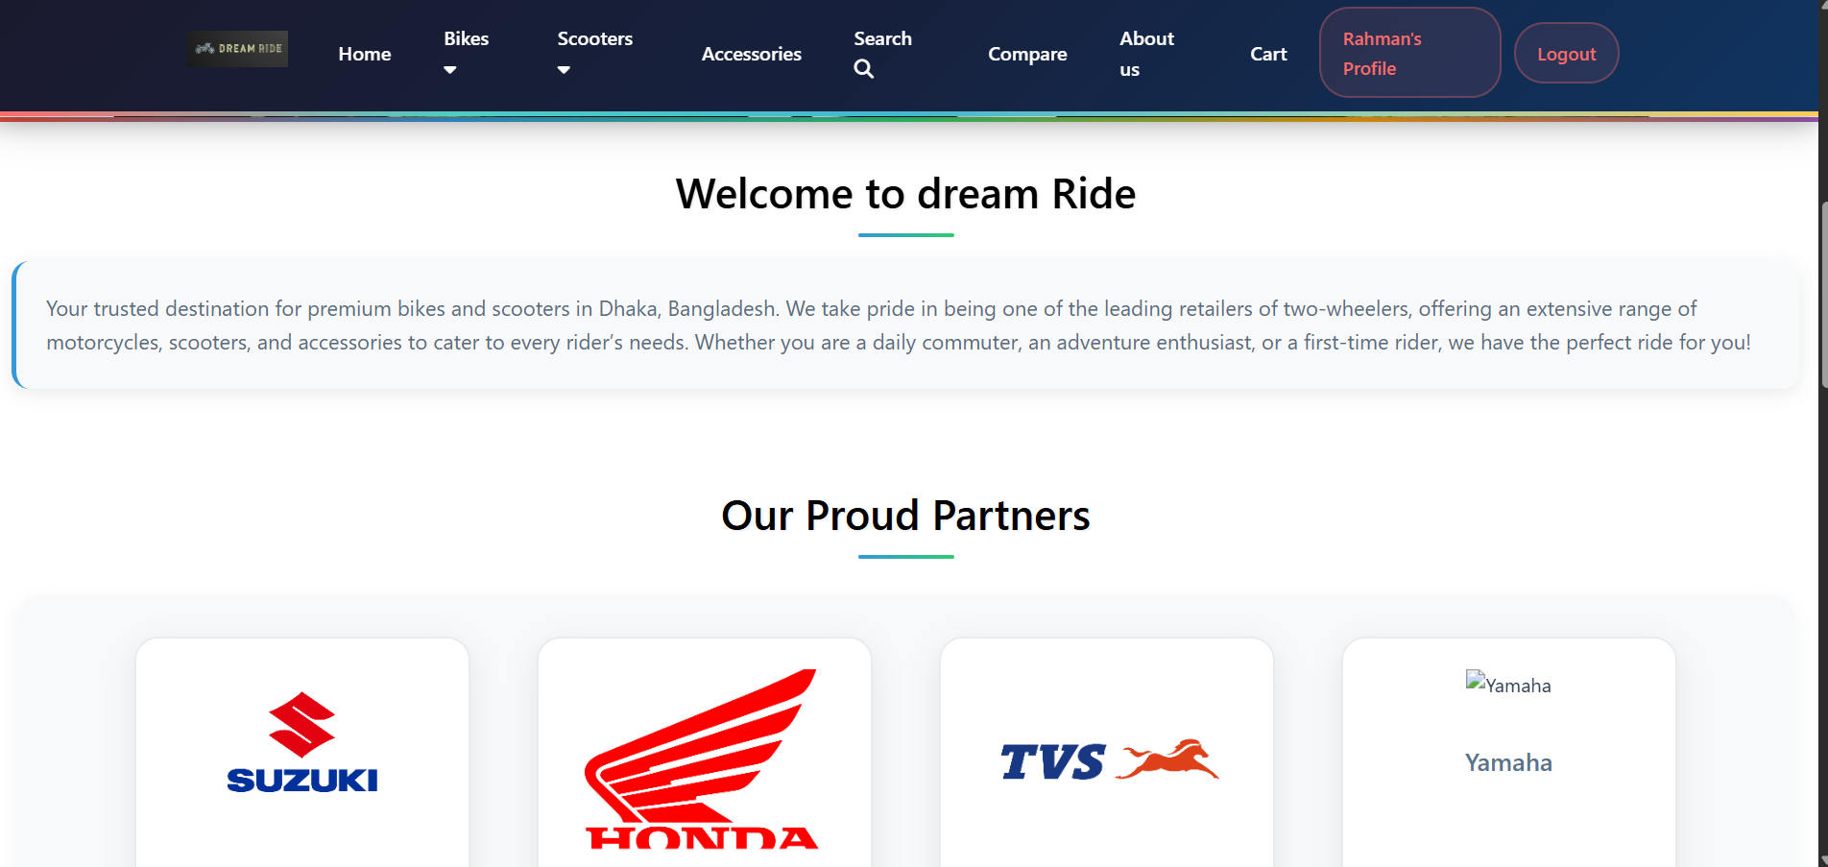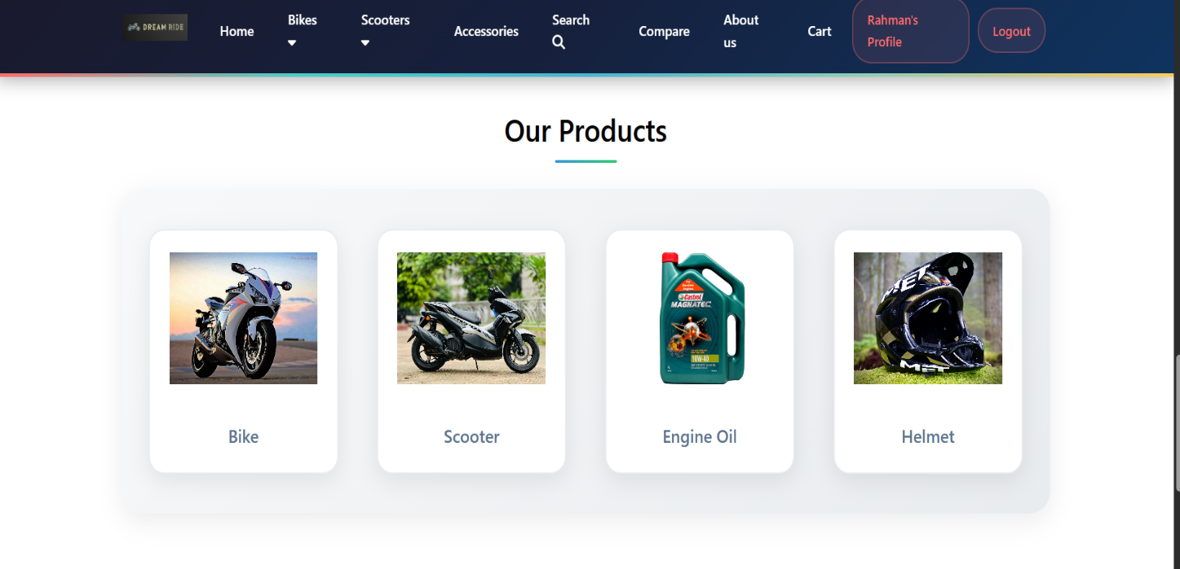

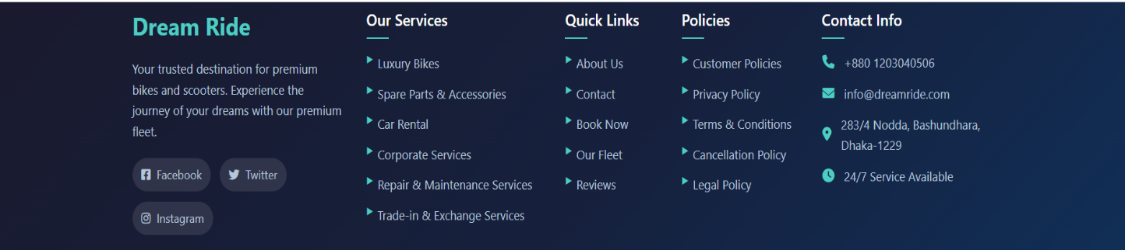

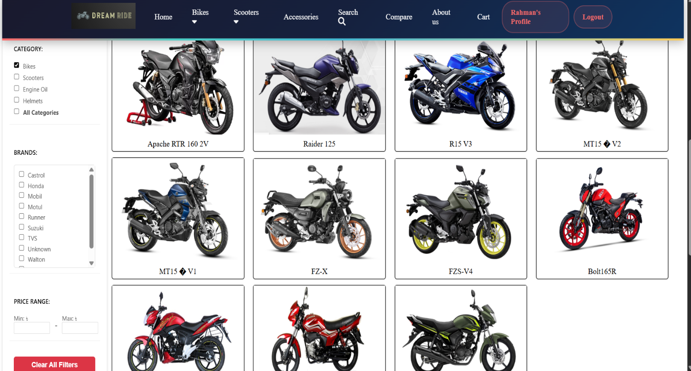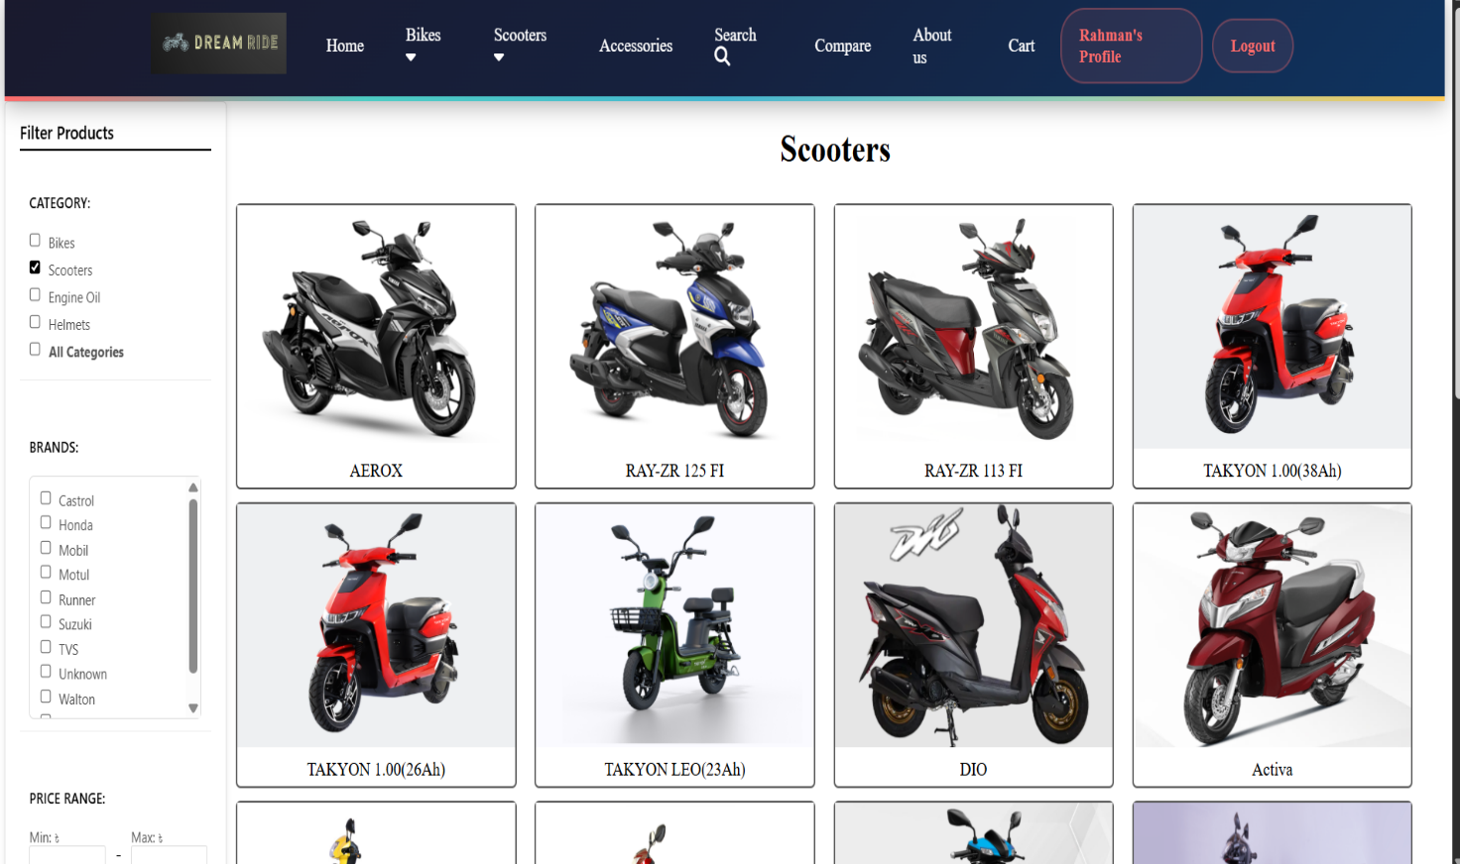

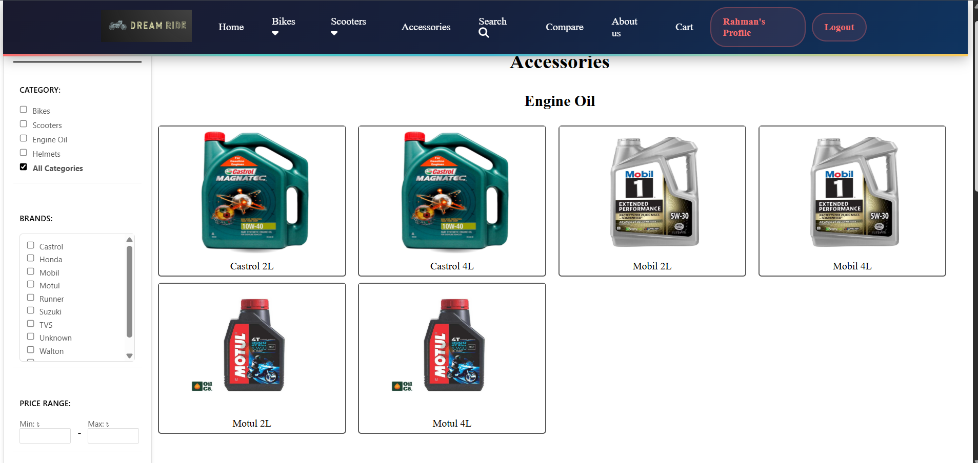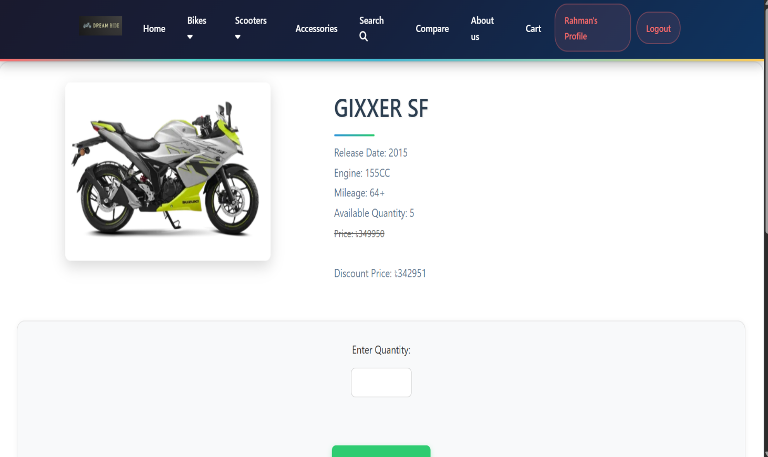

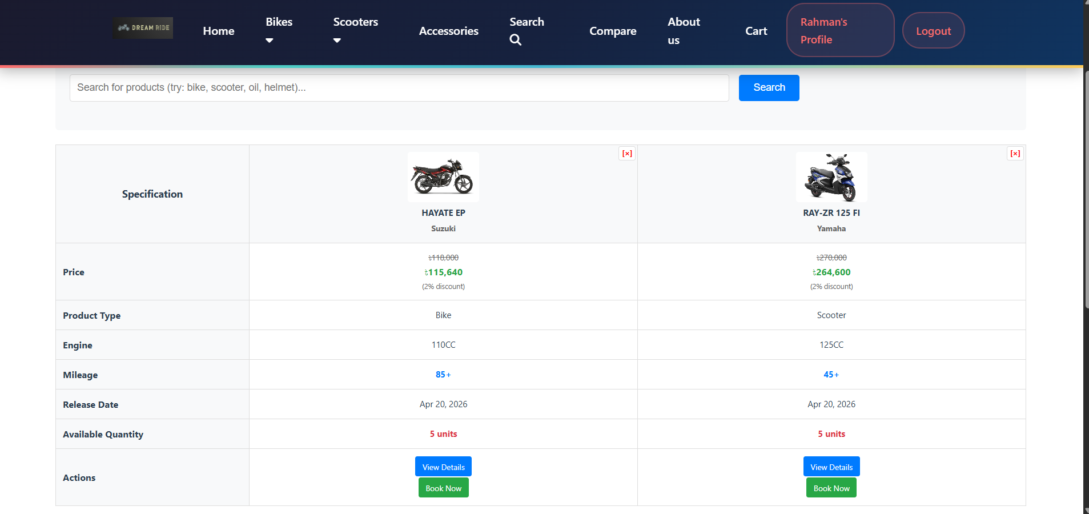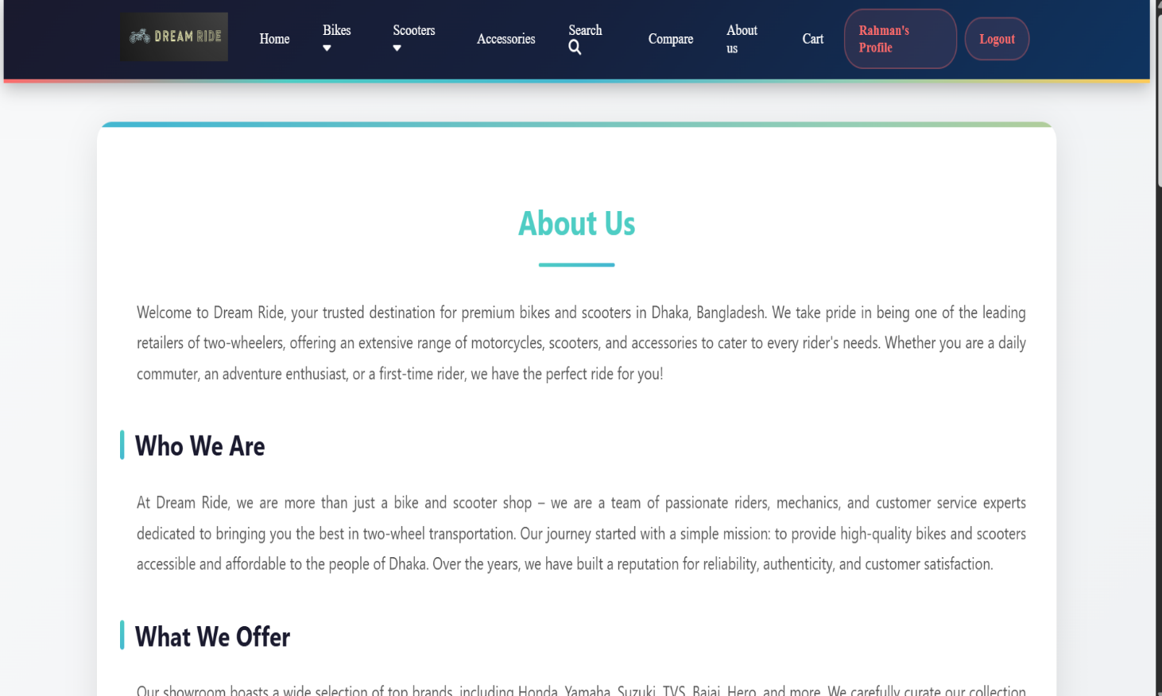

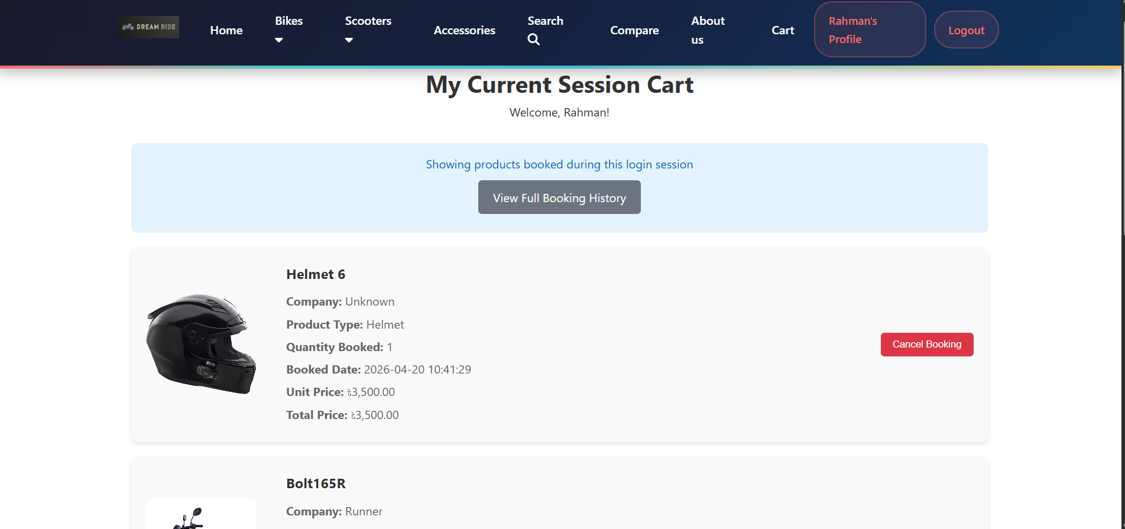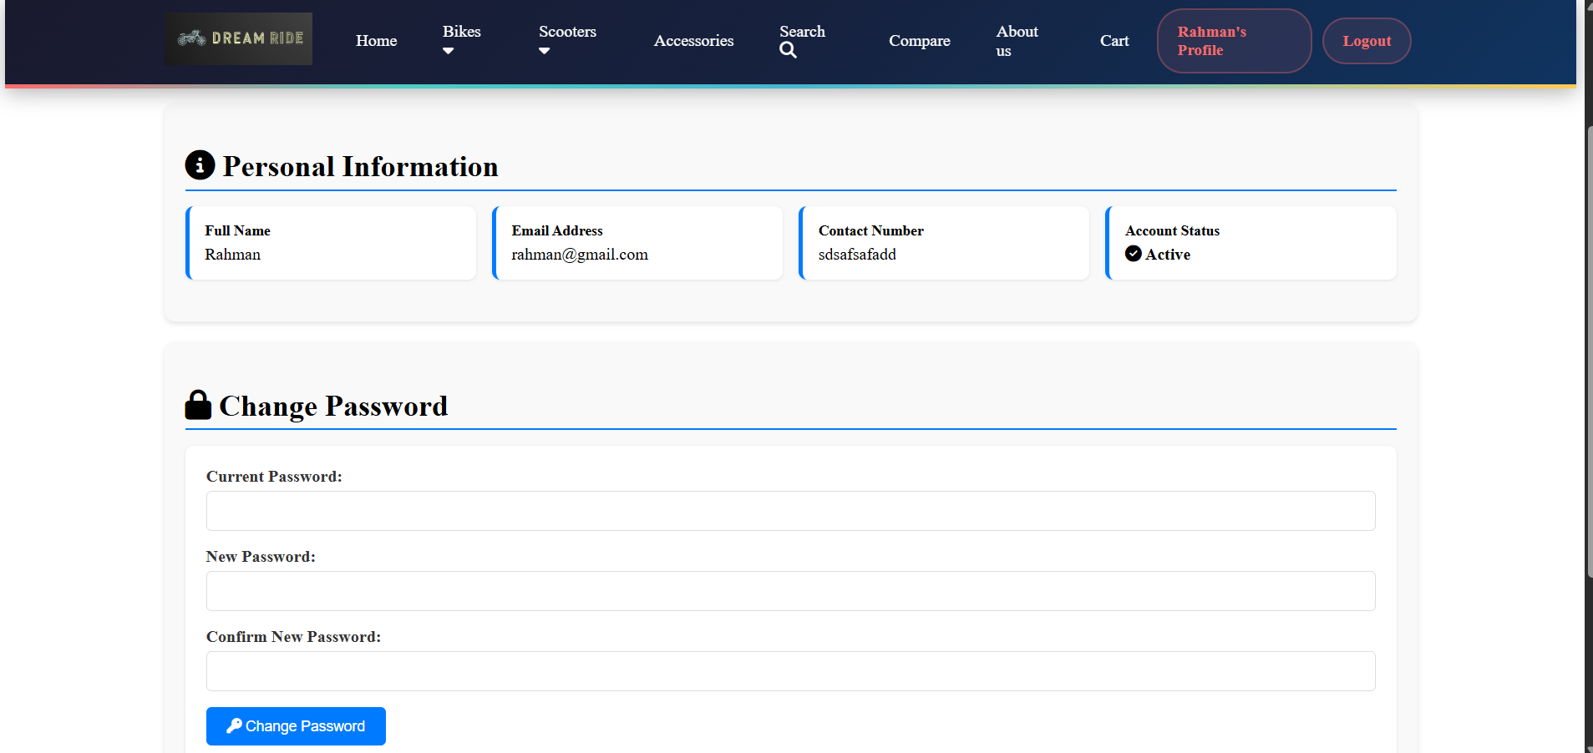

Codes(Customer Part):
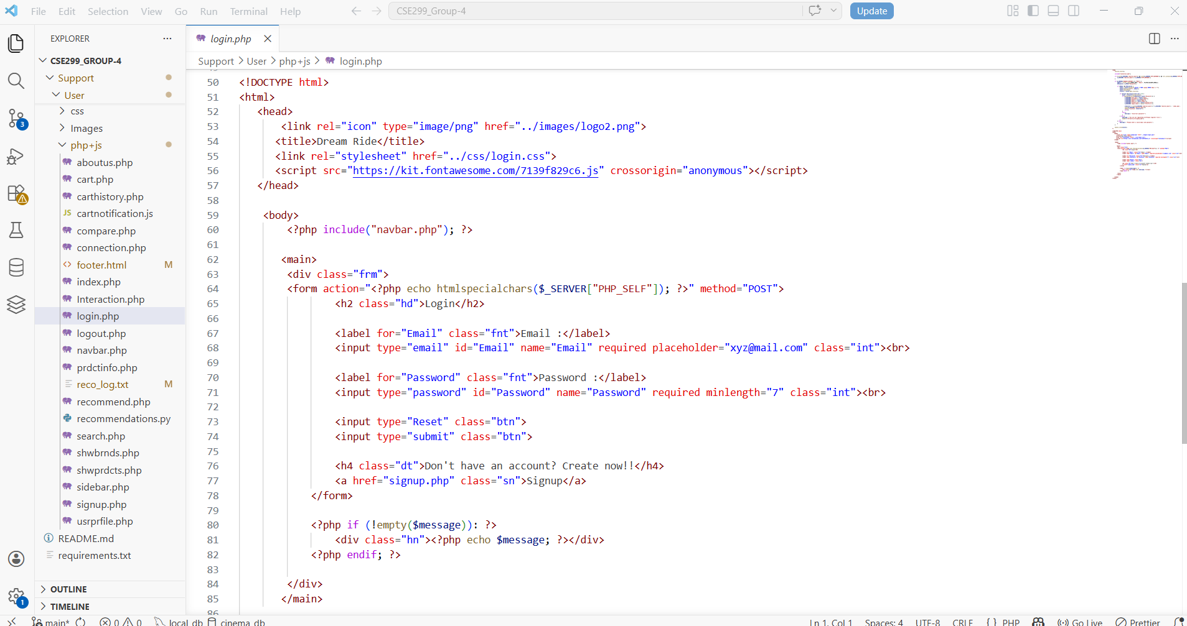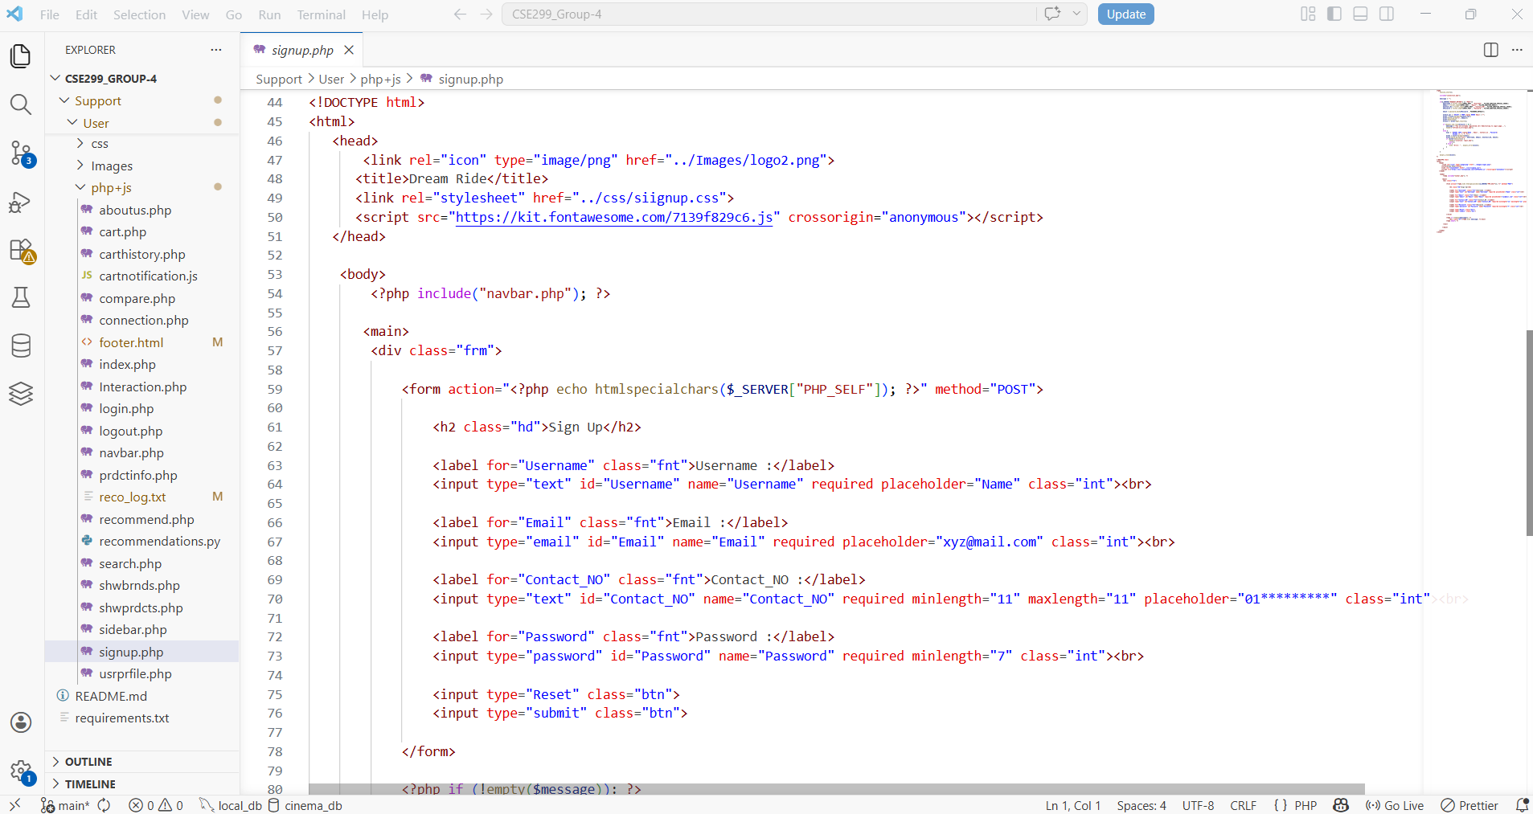

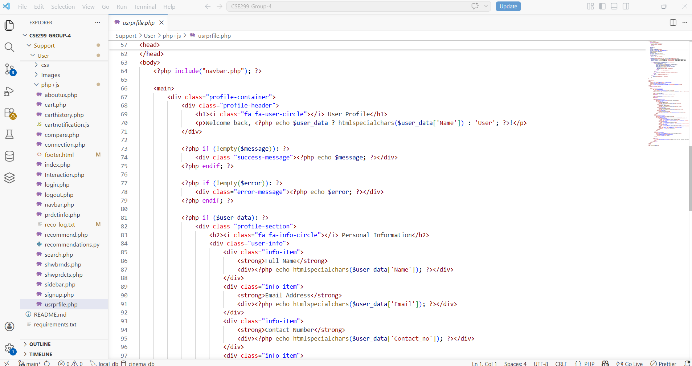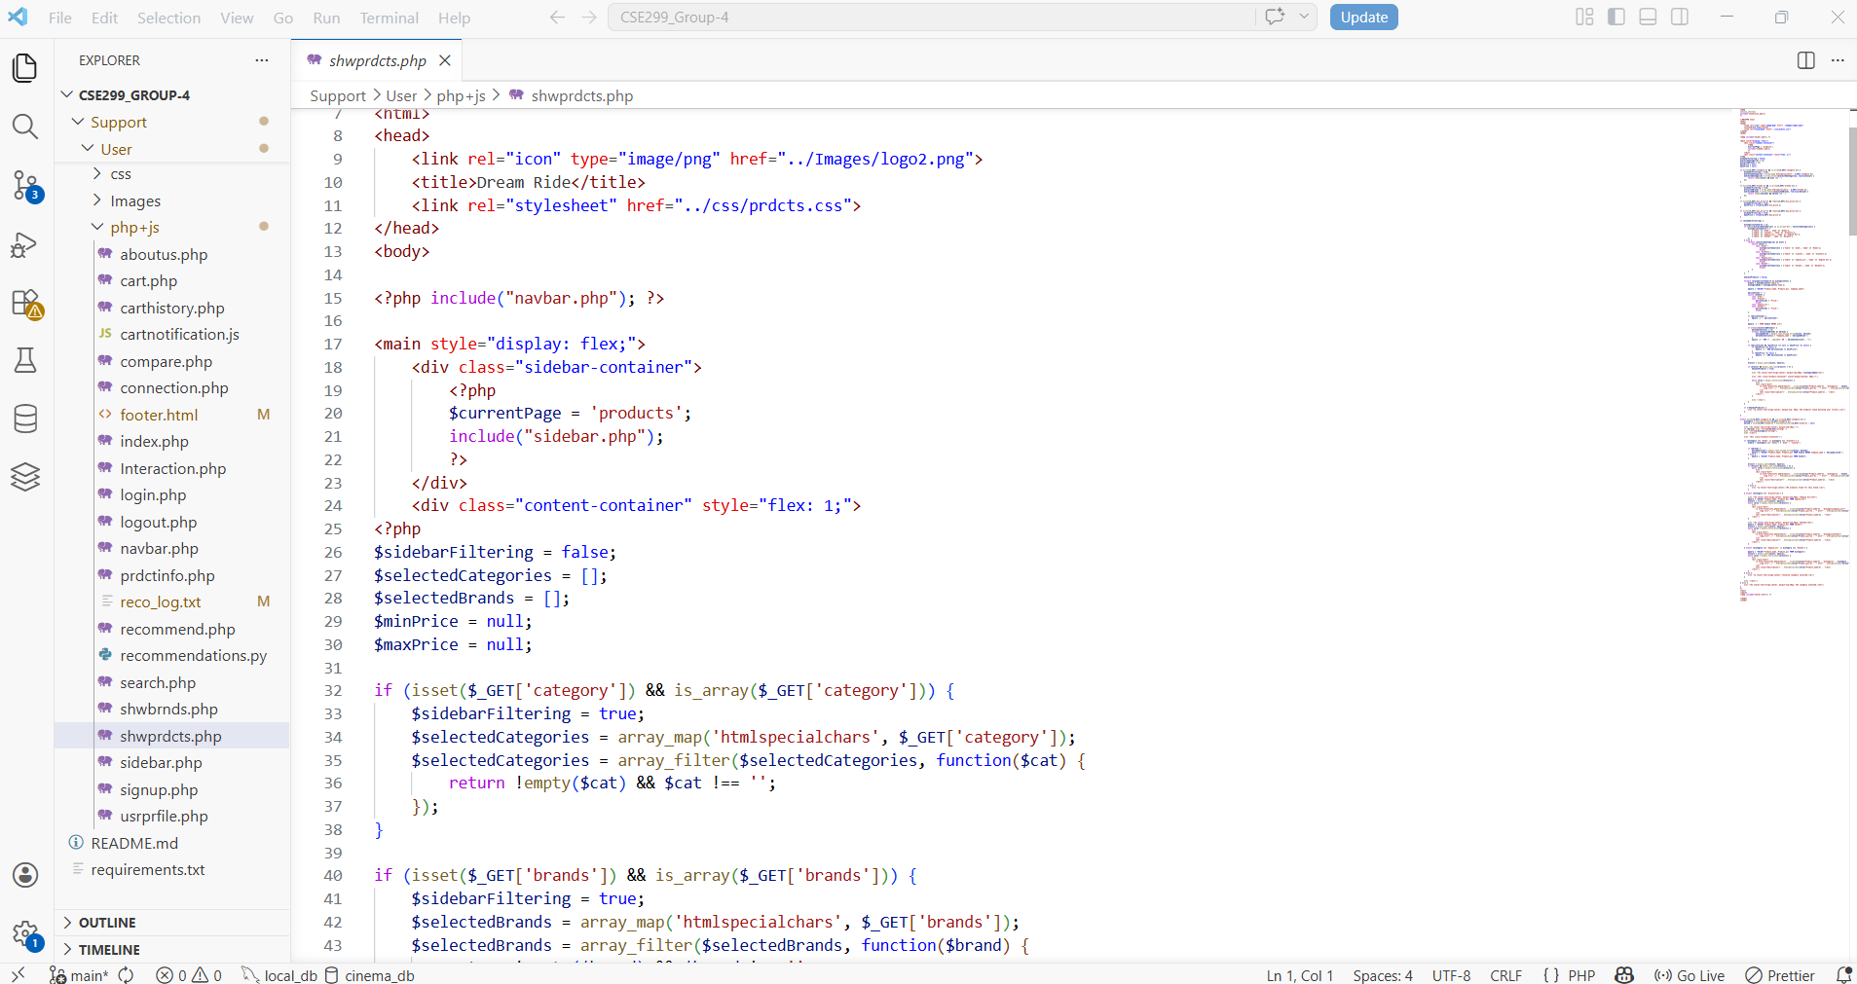

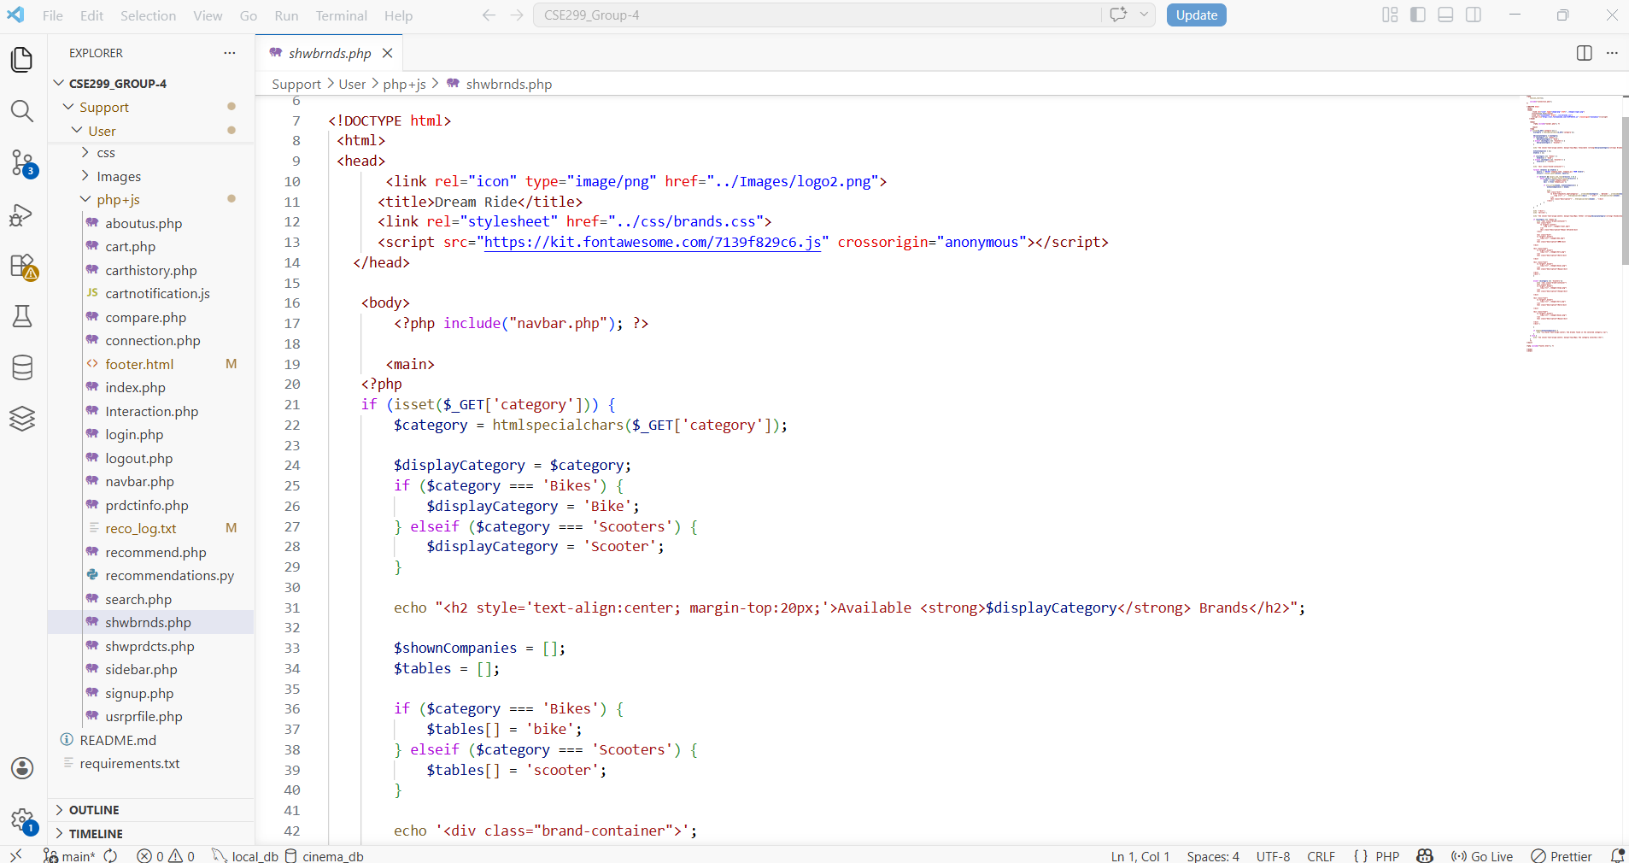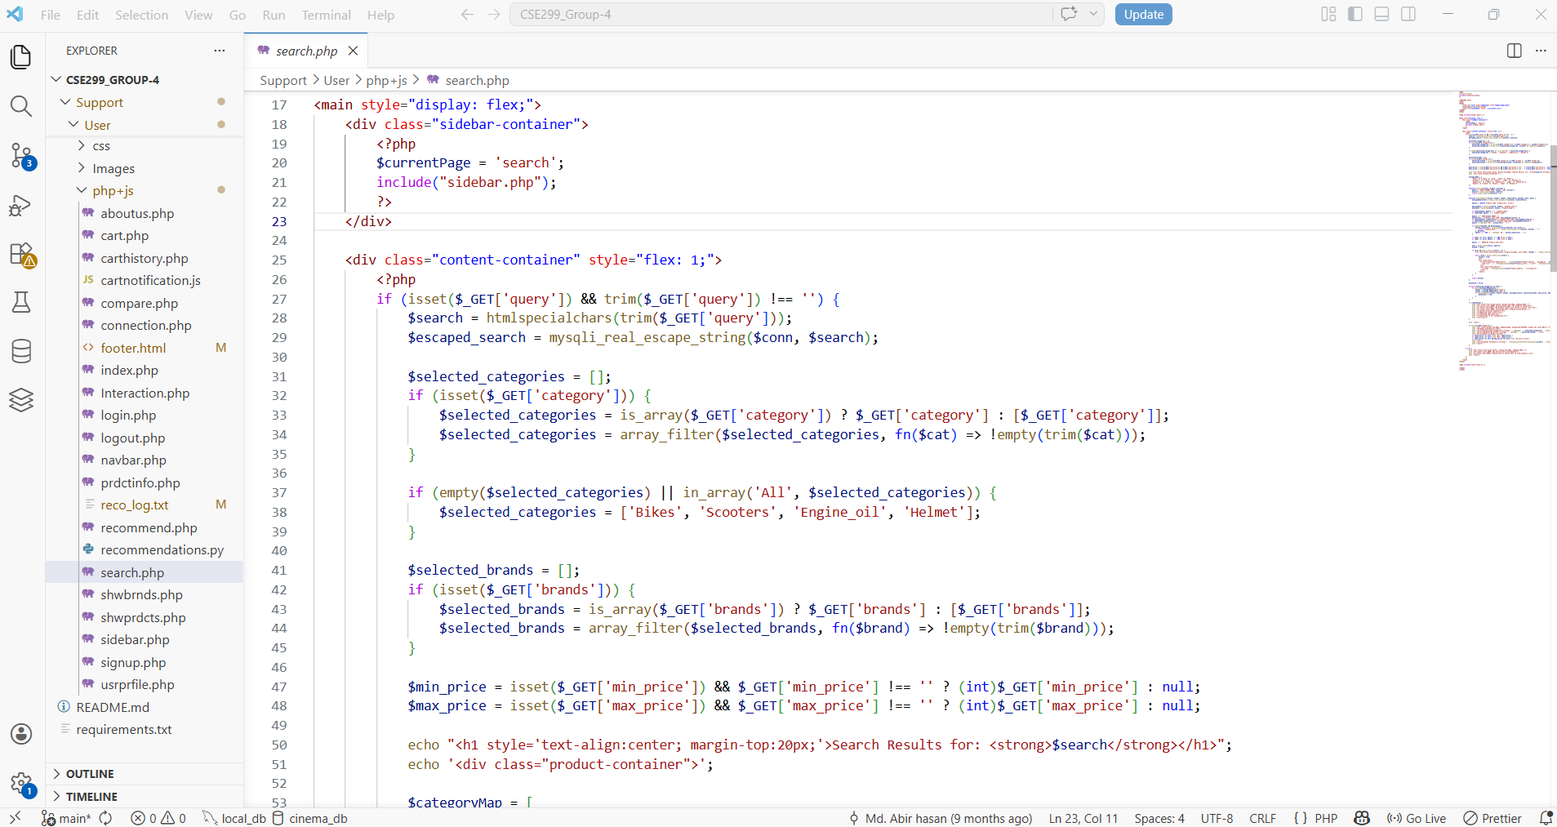

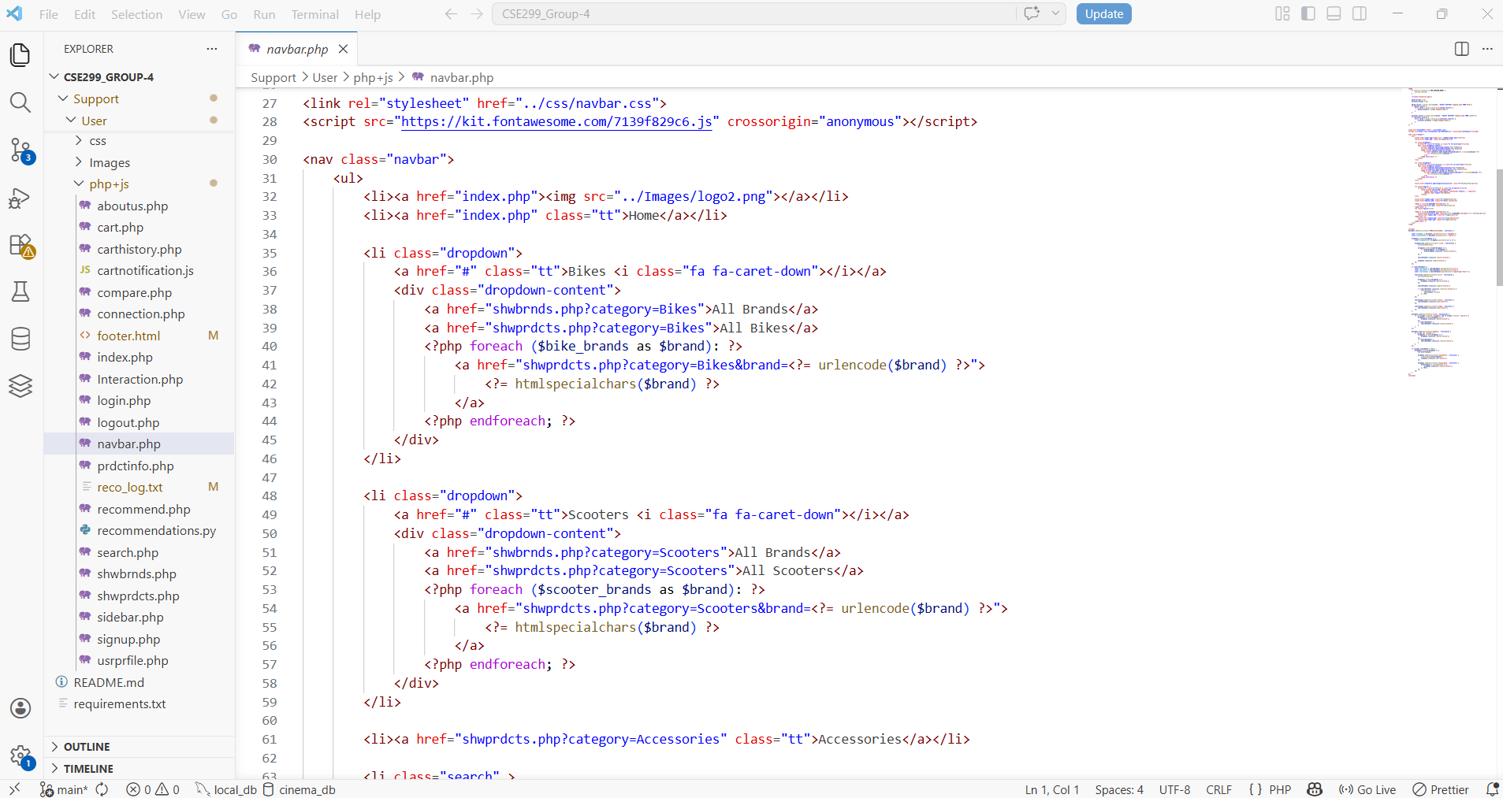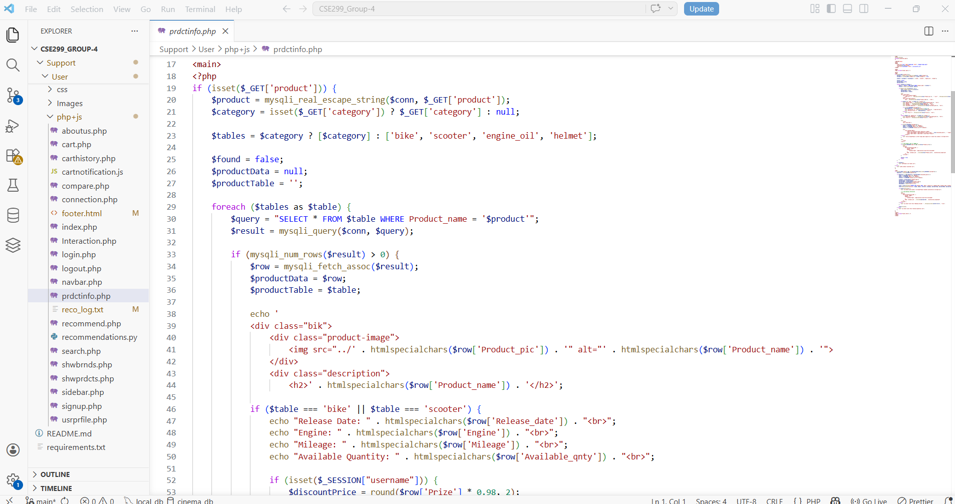

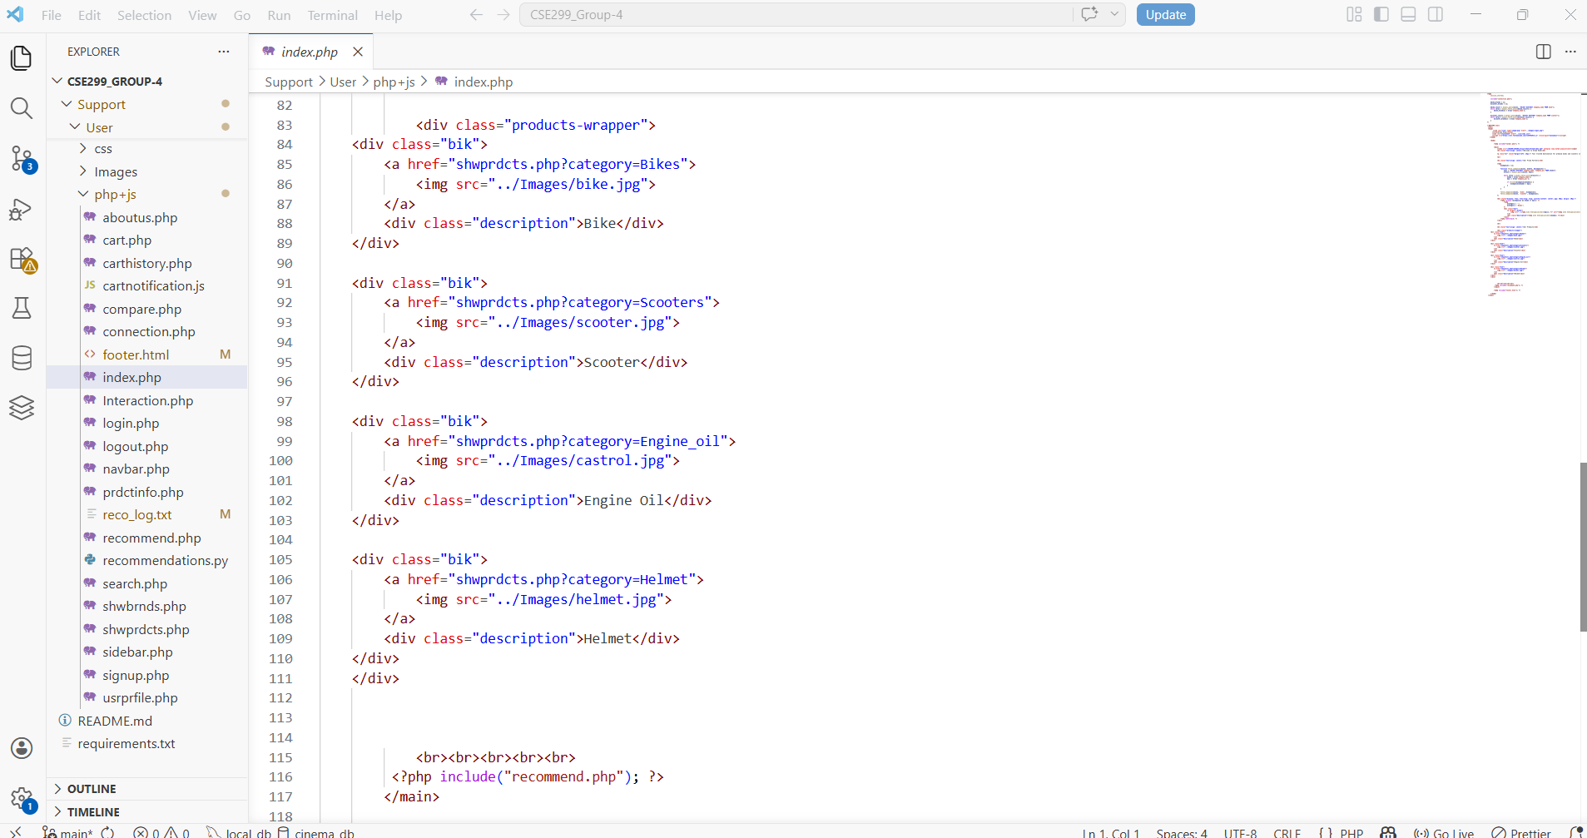

Snippets(Manager Part):



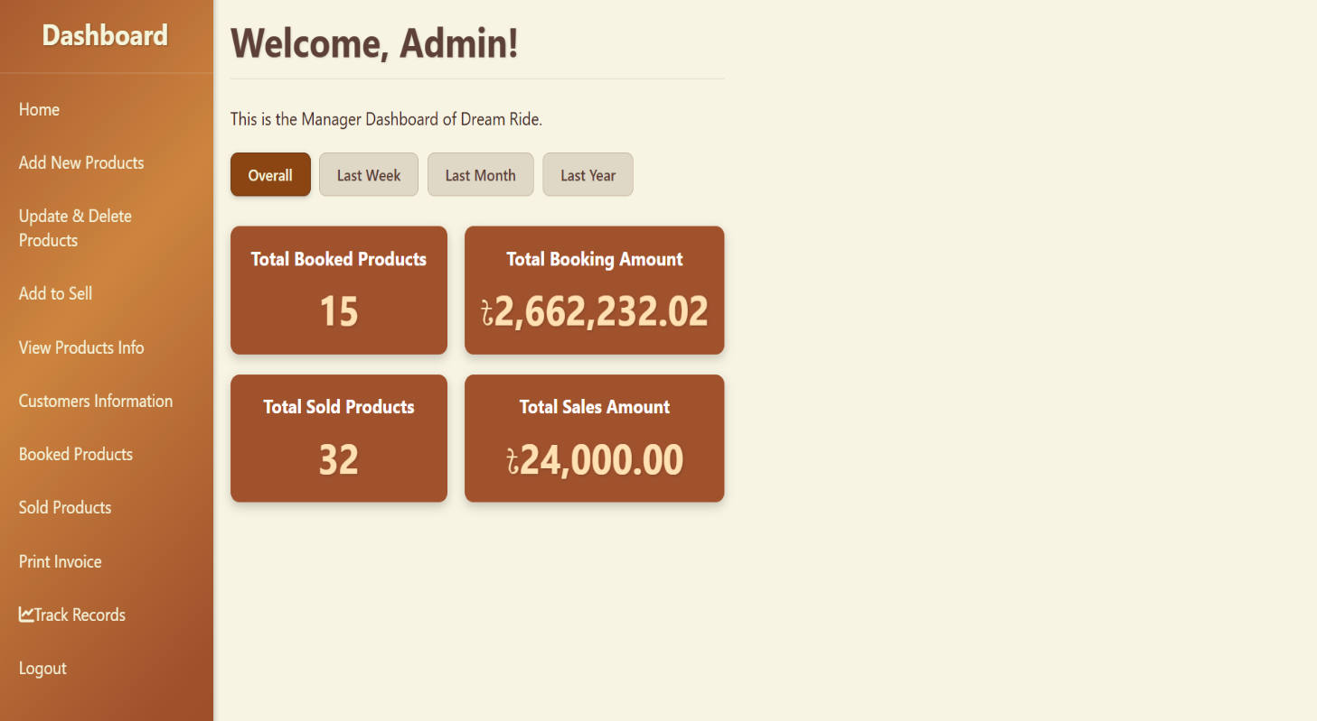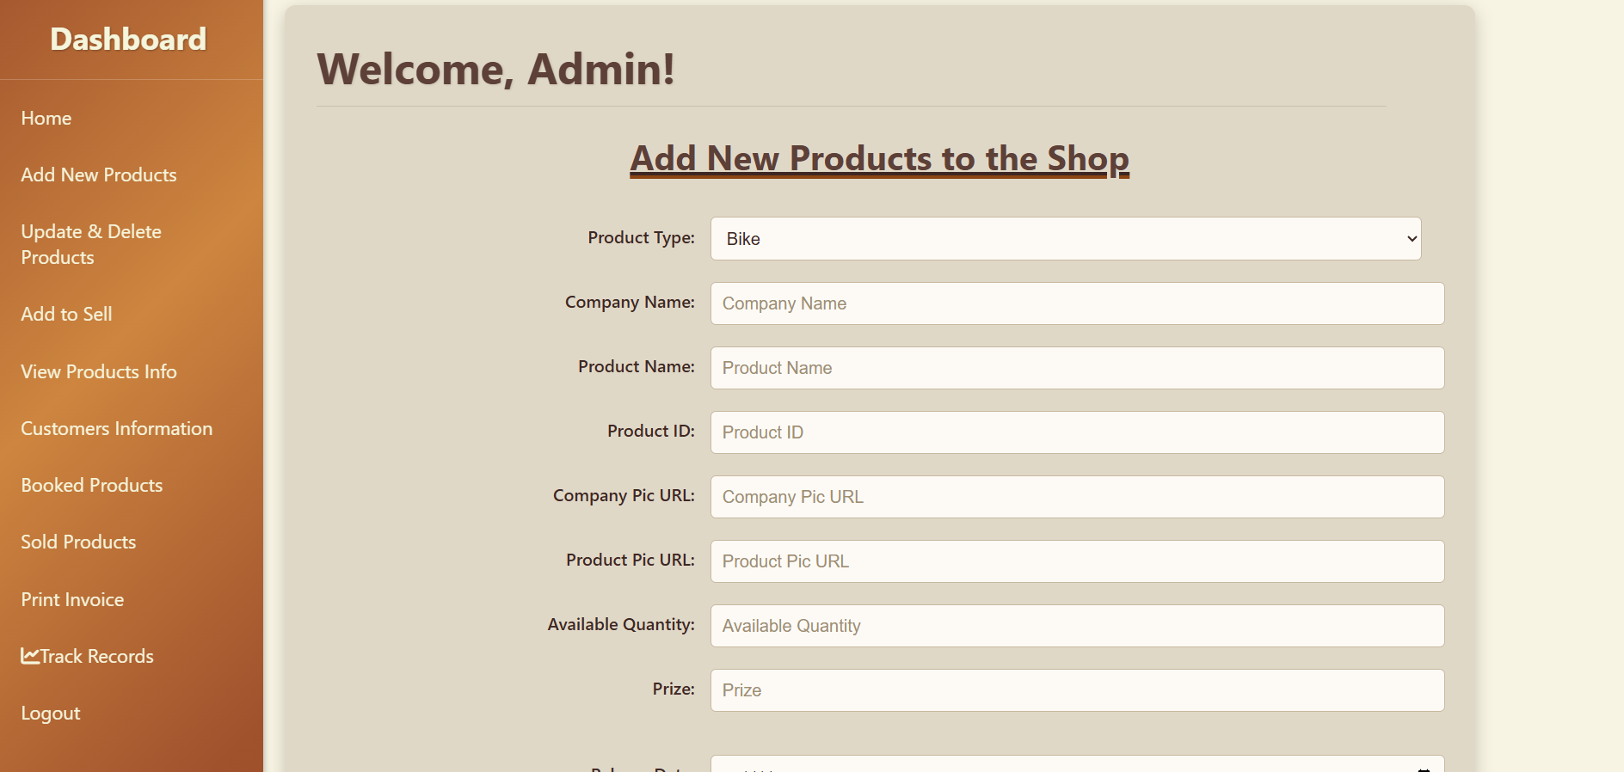

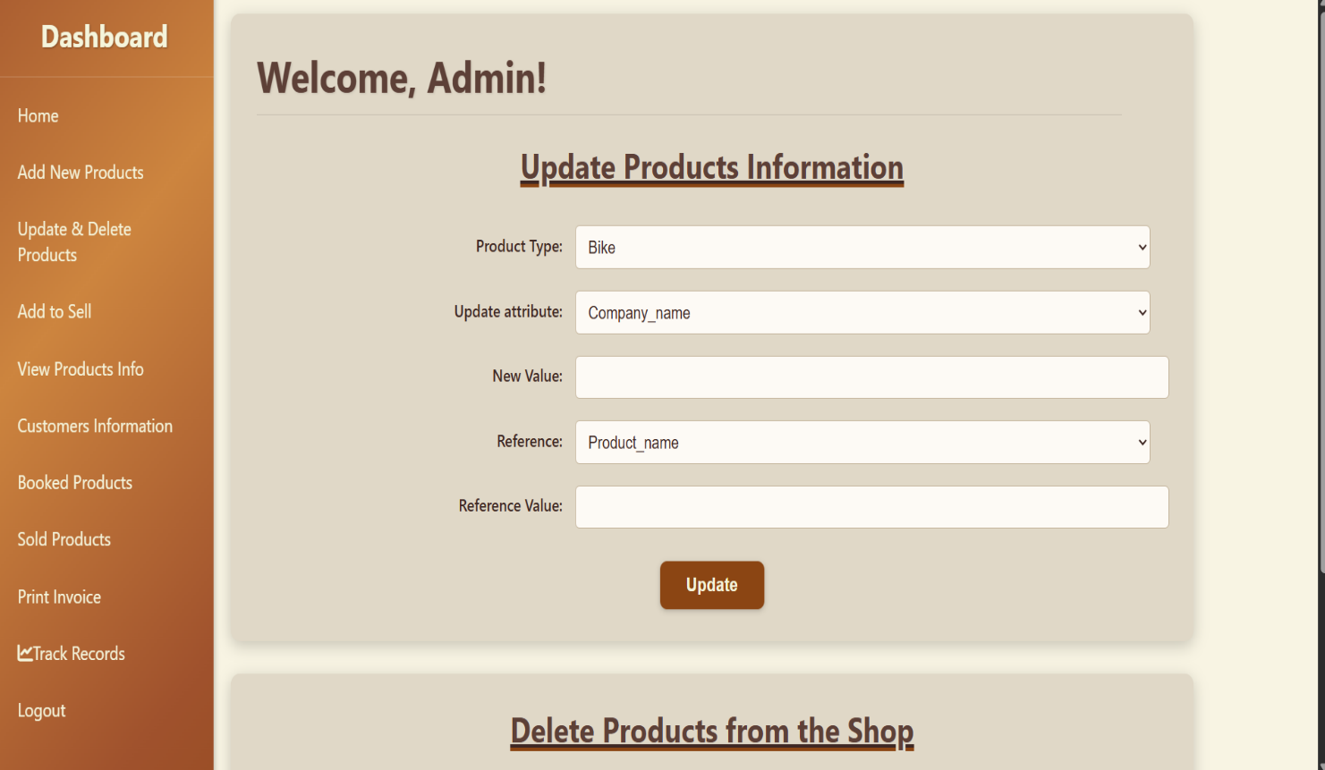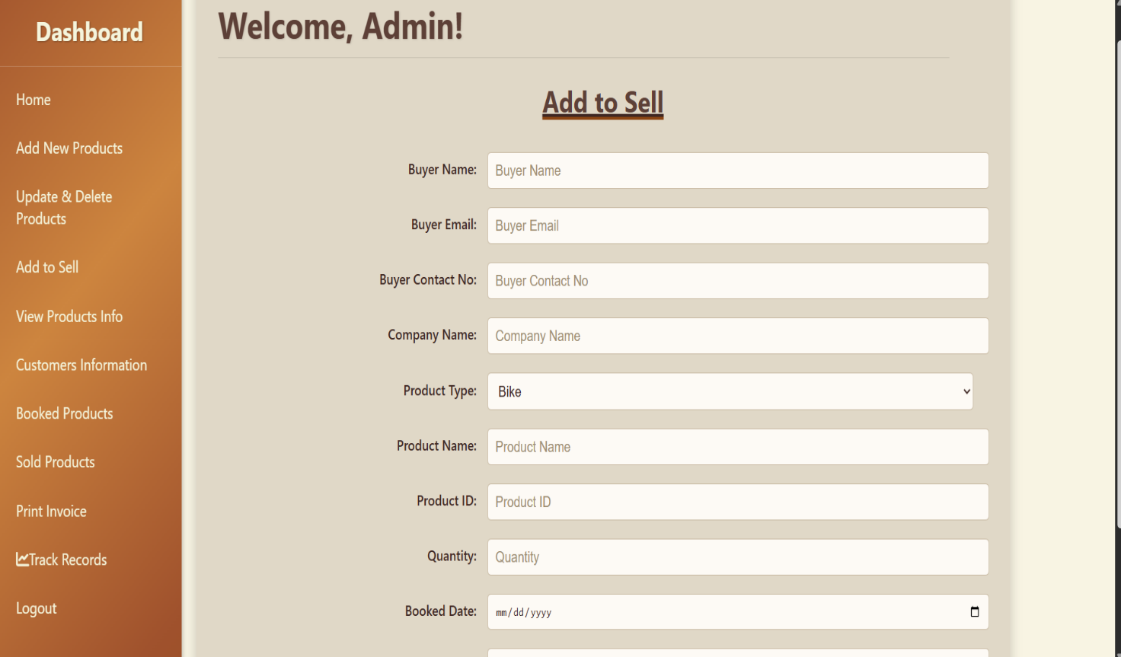

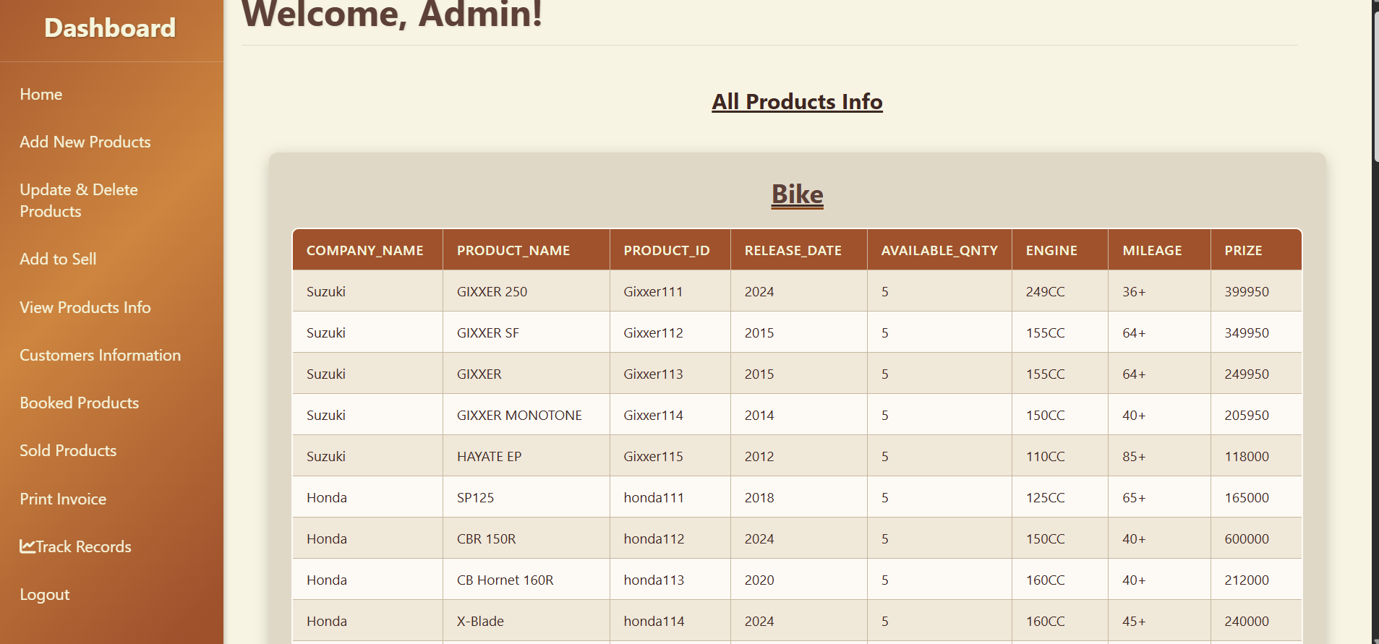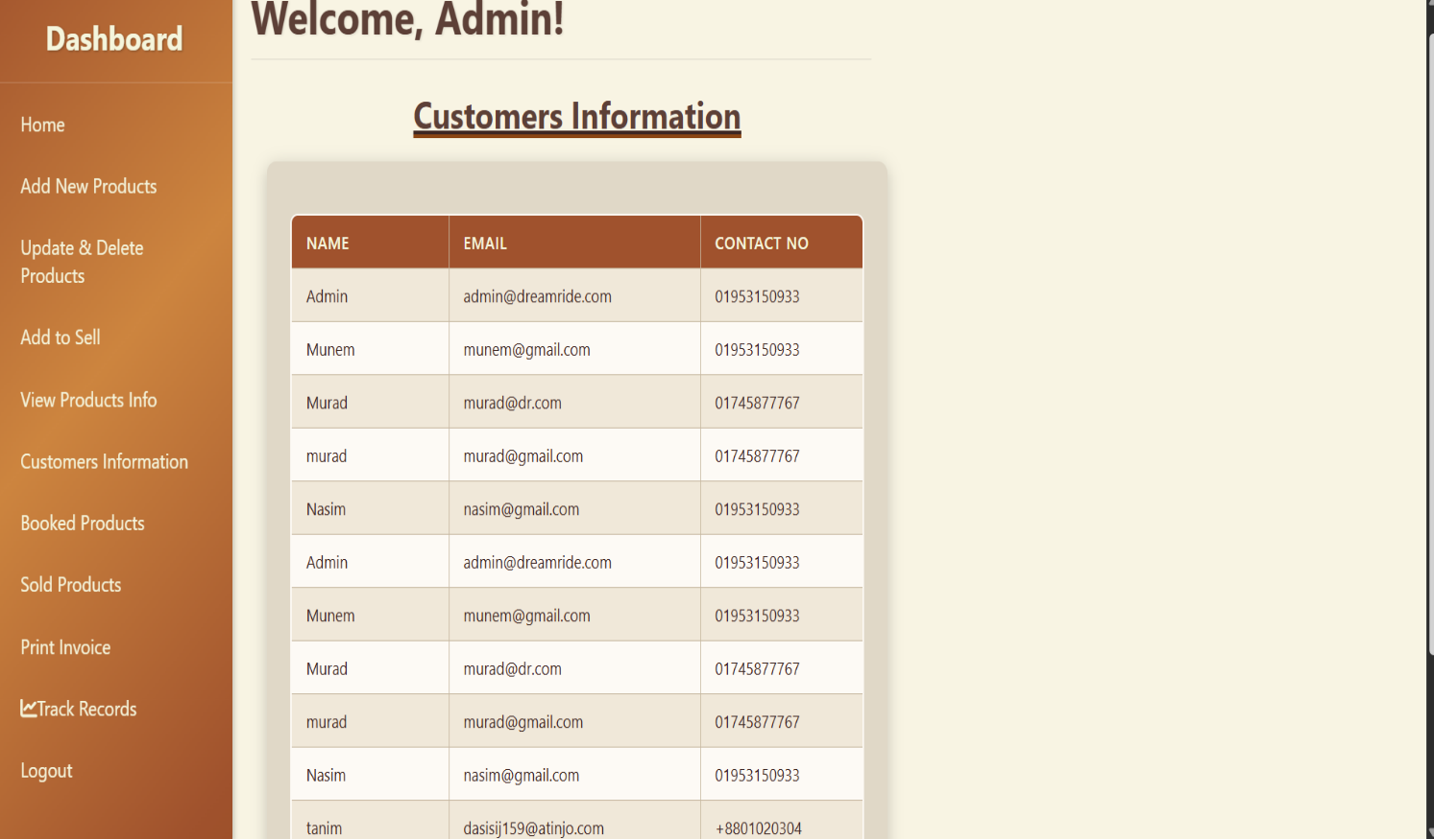

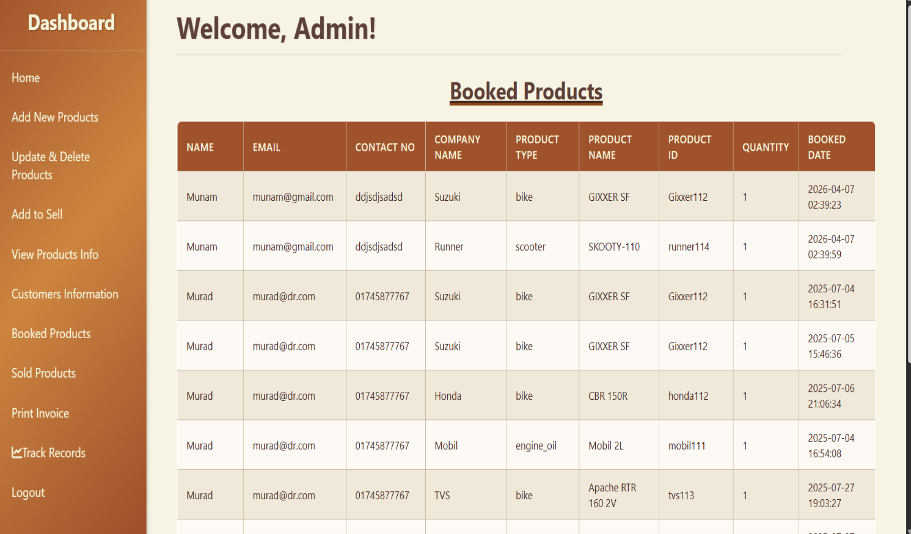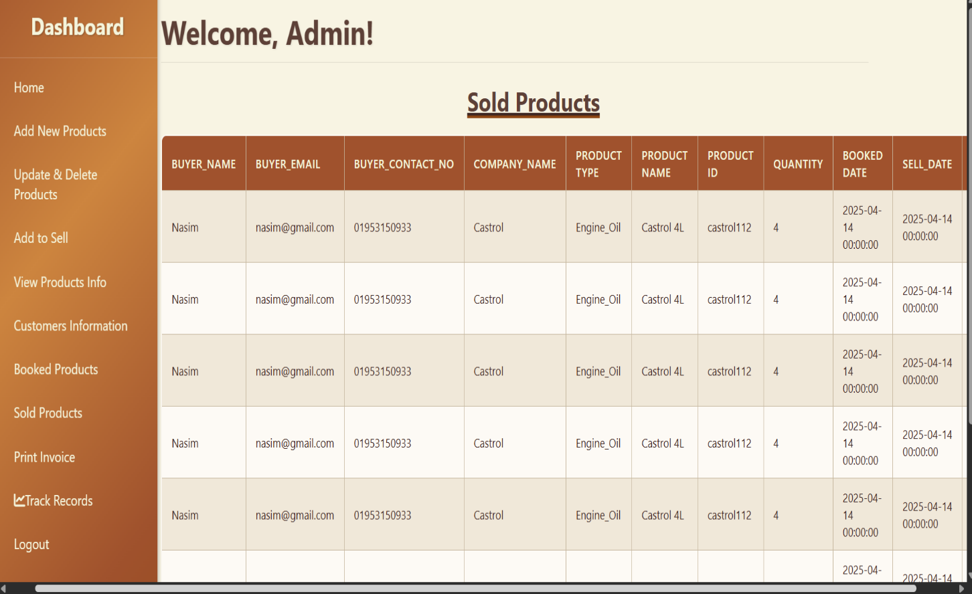

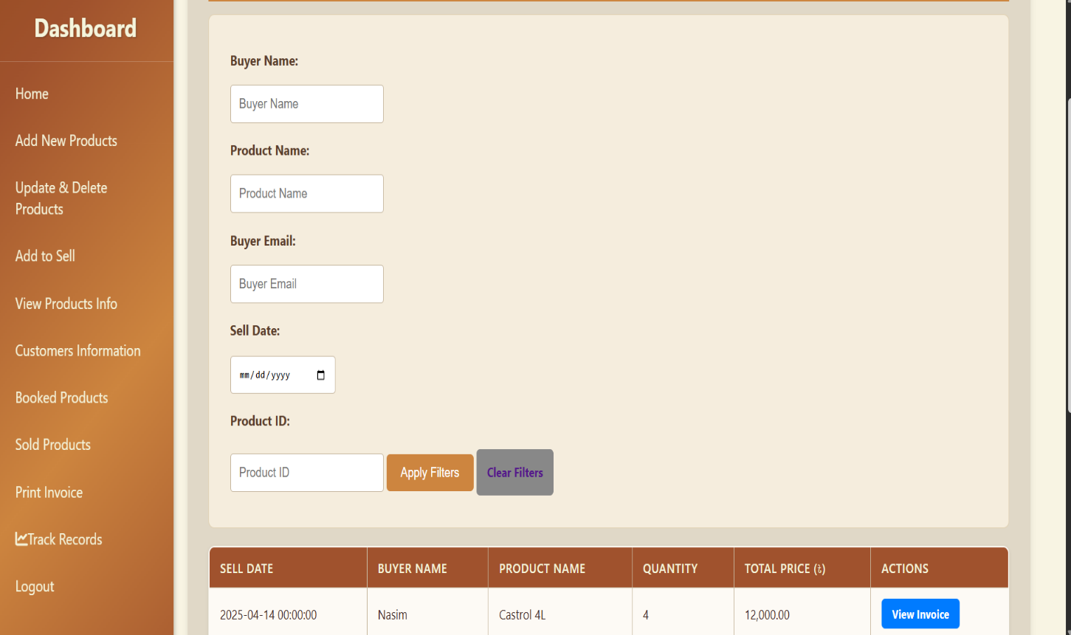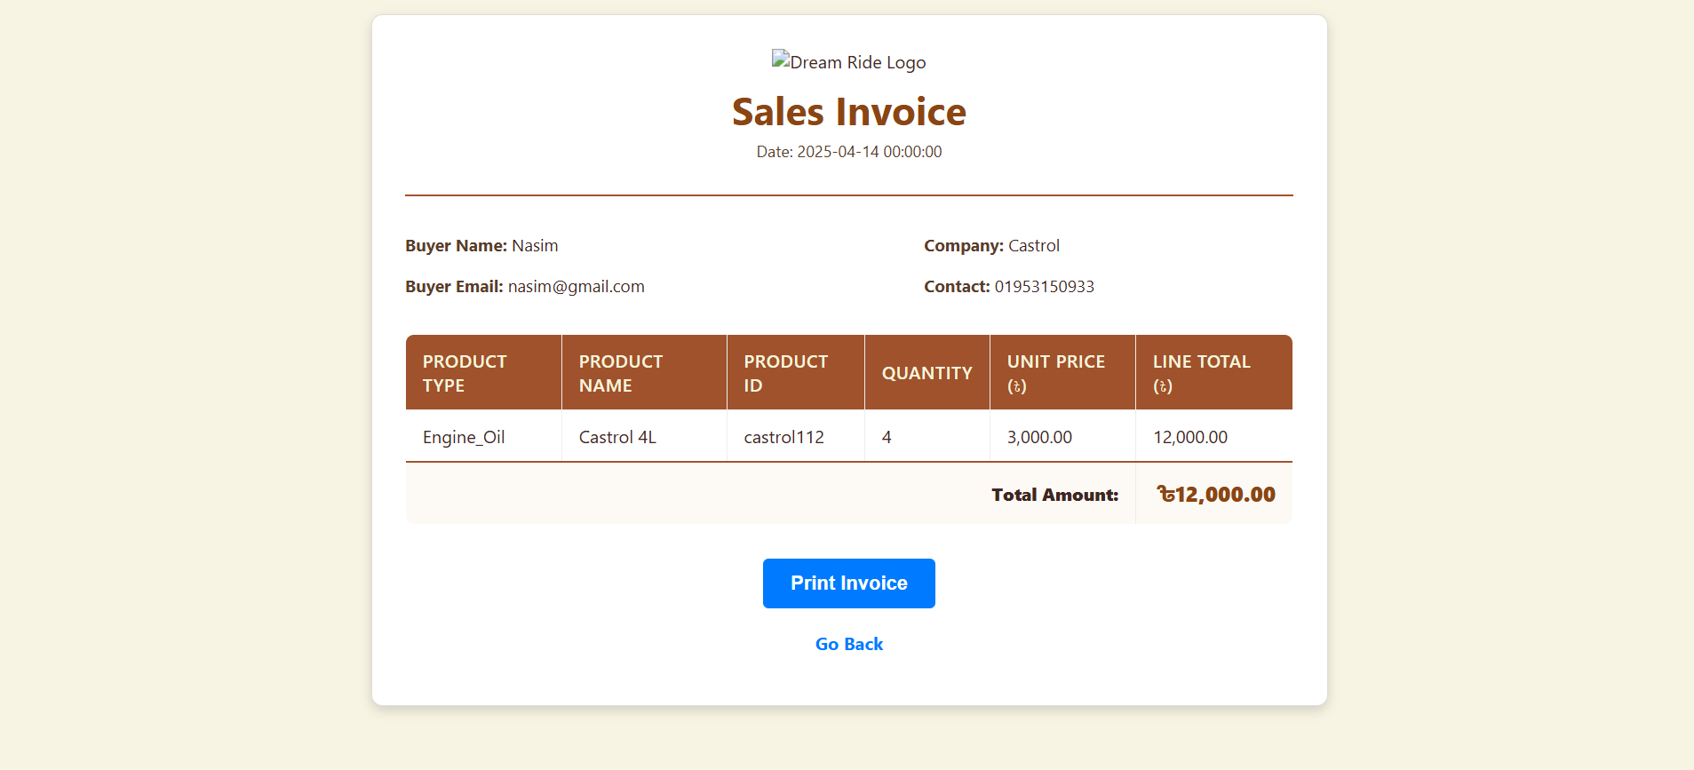

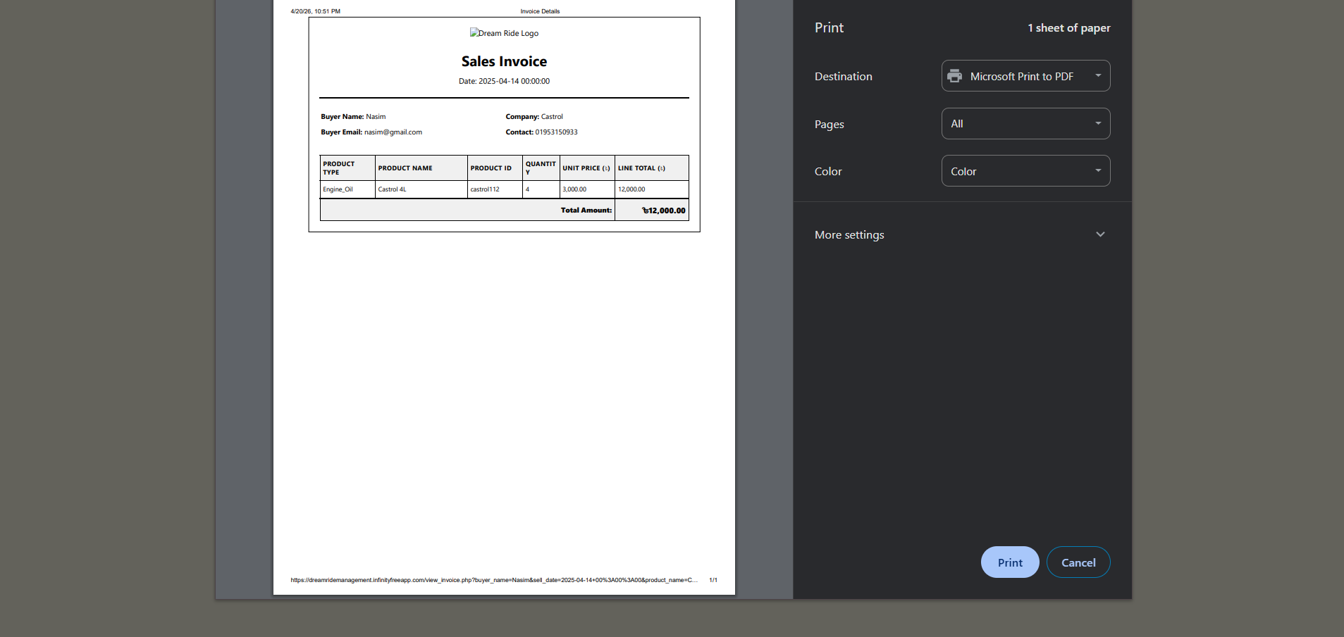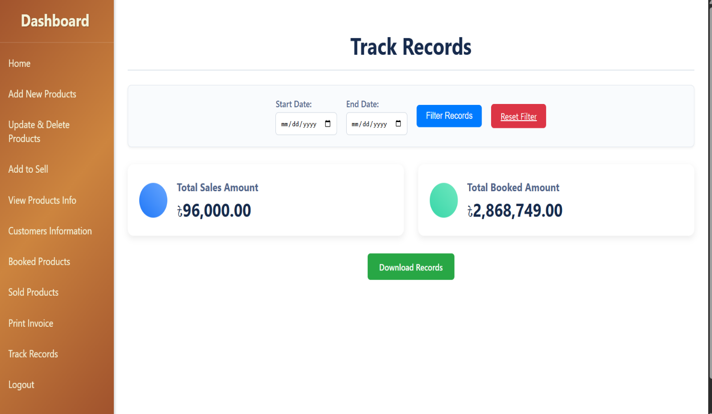
Codes(Manager Part):
